Eunice (Duhe) Tassin
January 27, 1917 – June 27, 2004

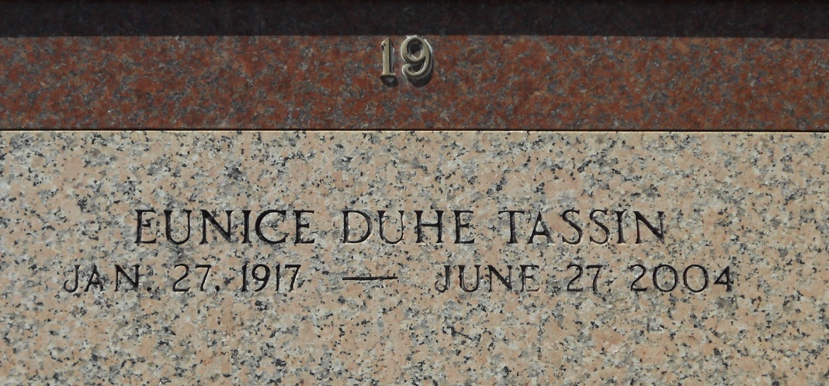
Photo by Team T-Lo

Eunice Duhe Tassin on Sunday, June 27, 2004 at 3:15 A.M.

Beloved wife of the late Norbert Tassin, Jr. Mother of Donald and Paul Tassin, Patricia Ocmand and the late Larry Tassin.

Daughter of the late Paul and Louise Duhe. Sister of Rosa Galatas, Early Duhe and the late Harris, Murphy, Lester, and LeRoy Duhe and Cecile Cooper. Also survived by 15 grandchildren, 19 great grandchildren and 2 step-great grandchildren. Age 87. A native and resident of Reserve, LA.

Relatives and friends of the family are invited to attend services. Visitation at MILLET-GUIDRY FUNERAL HOME, 2806 W. Airline Hwy, Laplace, LA on Wednesday, June 30, 2004 from 5:00 P.M. until 9:00 P.M. and on Thursday from 10:00 A.M. until 11:45 A.M. Followed by religious services at St. Peter Catholic Church, Reserve, LA at 12:00 Noon. Burial in church cemetery.

The Times-Picayune, New Orleans, Louisiana
June 29, 2004

