Paul Anthony Tassin
January 7, 1943 – August 6, 2013

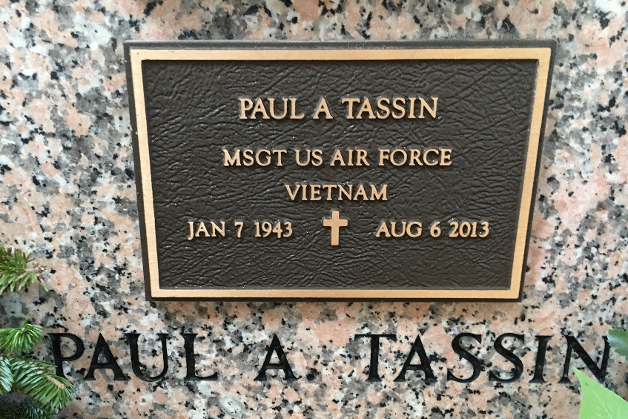
Photo by Team T-Lo

Paul Anthony Tassin went home to our Heavenly Father on August 6, 2013, peacefully, with family at his side.
Married to his wife, Janice Jacob Tassin for 48 years. Son of the late Norbert Tassin, Jr. and the late Eunice Tassin. Father of Troy Tassin and Dana Tassin Mulkey. Proud Paw Paw to Trace and Madison Tassin, Erica "Toot" Tassin, Amanda and Kristin Firmin, Billy Mulkey III and Zachary Mulkey. Great-grandpa to Ryley Onebene. Brother of Donald Tassin, the late Larry Tassin, and Patricia Ocmand. Father-in-law to Robin Tassin.
Paul served in the USAF active duty forces for many years, ending his career as a recruiter, effectively retiring with the rank of Master Sergeant.
Visitation will be at Ascension of Our Lord Catholic church in LaPlace, LA from 9:30 a.m. until 11:00 a.m. on Friday, August 9, 2013 followed by a Mass of Christian Burial at 11:00 a.m. Entombment will be in St. Peter Cemetery, Reserve, LA. ROSE LYNN FUNERAL SERVICES, 1870 Cabanose Ave., Lutcher, LA, is in charge of the arrangements.

The Times-Picayune, New Orleans, Louisiana
August 7-9, 2013

