Shannon J. Tassin Sr.
October 10, 1960 – November 10, 2014

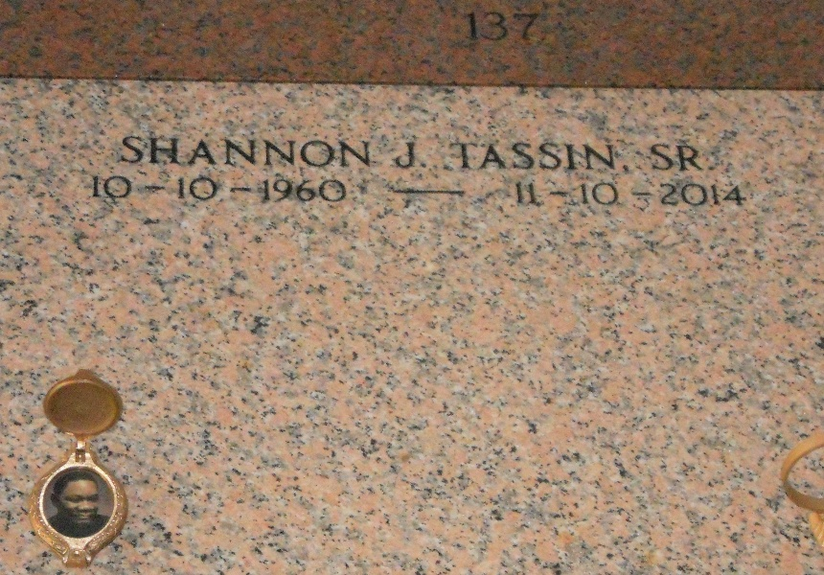
Photo by Team T-Lo

SHANNON TASSIN, SR "SHAN-DING" in a car accident on Monday, November 10, 2014.
Son of the late Earnest and Shirlean Tassin. Father of Tantalan, Sedrick, Tyler and Shanlon Tassin and the late Shannon Tassin, Jr. Brother of Cabrini Tassin, Elston "Petot" Tassin and the late Kathy Jones. Also survived by 3 grandchildren, a host of nieces, nephews, cousins, other relatives and friends. Age 54 years. A native and a resident of Reserve, LA.
Relatives and friends of the family, also pastors, officers and members of Milesville Church of God in Christ, Greater New Plymouth Rock Baptist Church and all neighboring churches are invited to attend the funeral service at Greater New Plymouth Rock Baptist Church, 110 NW 13th St., Reserve, LA on Saturday, November 15, 2014 at 10:00 AM. Rev. David B. Carter, Pastor. Rev. Ronald Frank, Pastor of Milesville Church of God in Christ, Officiating. Burial will be private. SERVICED BY ROBOTTOM

The Times-Picayune, New Orleans, Louisiana
November 13-13, 2014

