Cornelia (Queen) Terrebonne
1883 – May 30, 1954
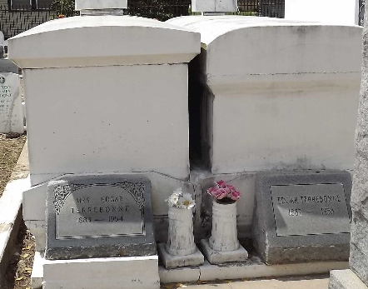

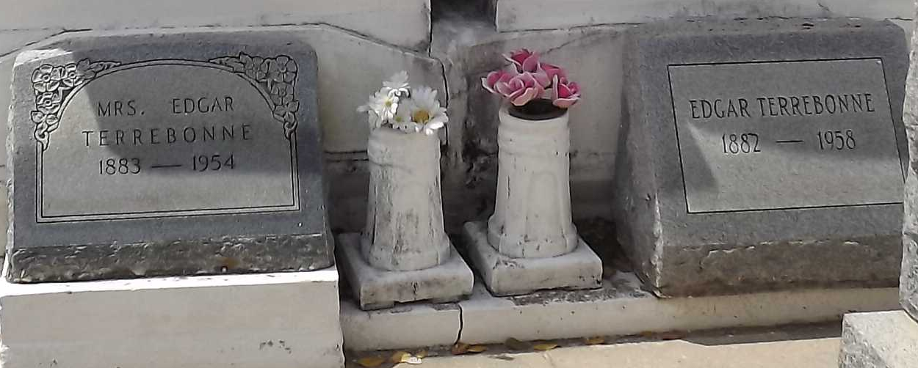
Photos by Mary Agnes Hammett

Terrebonne – On Sunday, May 30, 1954 , at 11:40 o’clock p.m. Cornelia Queen, beloved wife of Edgar Terrebonne, mother of Robert Terrebonne, also survived by two grandsons; age 69 years.

Relatives and friends of the family are invited to attend the funeral, which will take place from Millet Funeral Home, Reserve, La., on Tuesday, June 1, 1954, at 8:30 o’clock a.m. followed by religious services at St. Hubert’s church, Garyville, La., at 9 o’clock.

Interment in St. Peter cemetery, Reserve, La.

The Times-Picayune, New Orleans, Louisiana
Tuesday, June 1, 1954, p. 2

