Ida (Estelle) Terrebonne
1905 – May 7, 1966
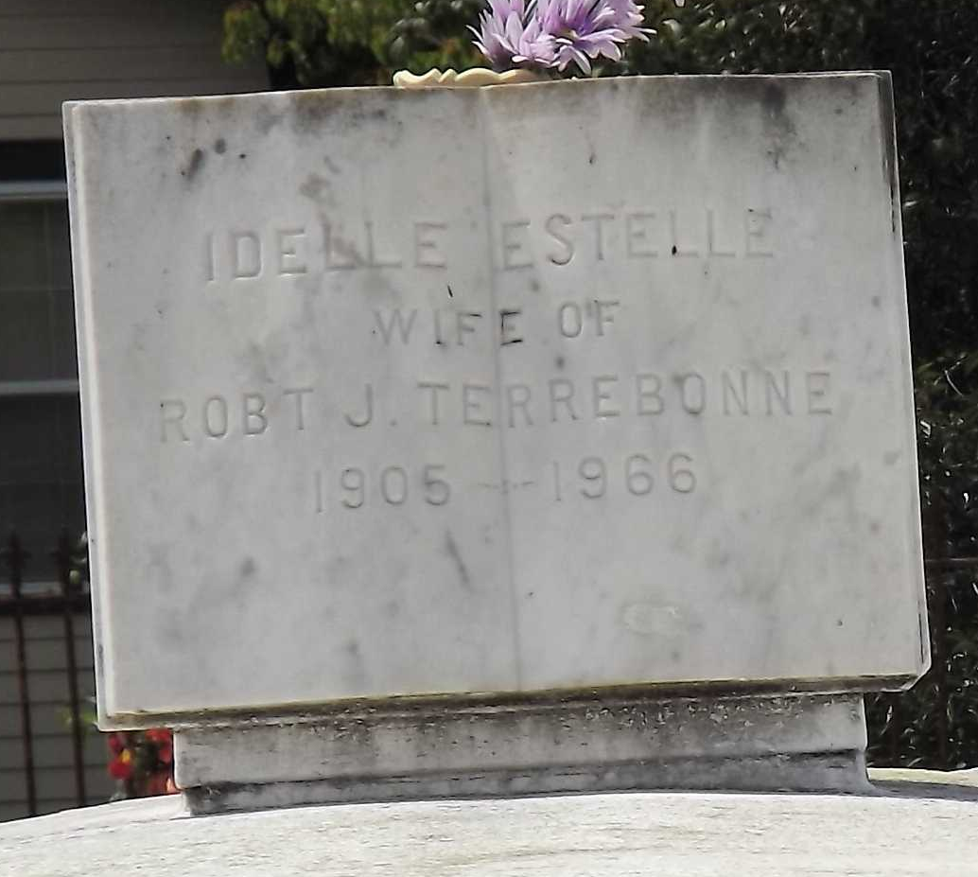
Photo by Mary Agnes Hammett

Terrebonne – At the residence, Mt. Airy, La., on Saturday, May 7, 1966, at 11:00 o’clock a.m., Idelle Estelle, beloved wife of Robert J. Terrebonne, mother of Robert L. Terrebonne of Laplace, La., and Richard P. Terrebonne, of Norco, La., sister of Mrs. V. Perez Sr., Miss Florence Estelle and Mrs. Beulah Malone of New Orleans, La., Mrs. Clarence Alleman, Mrs. Henry Adam of Flanklin (sic), La. and the late Rives, Ferdinand and Willie Estelle, also survived by 6 grandchildren, age 60 years, a native of Franklin, La. and a resident of mt. Airy, La., for the past 21 years.
Relatives and friends of the family are invited to attend the funeral. Services from Millet Funeral Home, Reserve, La., on Tuesday, May 10, 1966, at 10:30 o’clock a.m. followed by religious services at St. Joan of Arc Church, Laplace La., at 11 o’clock a.m.
Interment in St. Peter cemetery, Reserve, La. Parlors will open Monday at 4:30 o’clock p.m.

The Times-Picayune, New Orleans, Louisiana
Monday, May 9, 1966
Section 1, p. 8

