Alton James Terrio
May 27, 1917 – April 12, 2008

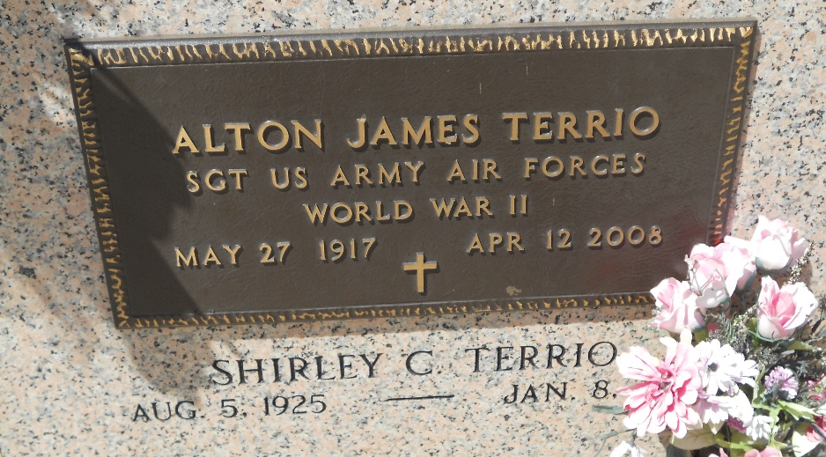
Photo by Team T-Lo

Alton J. Terrio on Saturday, April 12, 2008 at 1:33 pm. Beloved husband of Shirley Cassagne Terrio. Father of Lee Terrio and Barry and wife Anne Iris Terrio. Grandfather of Melissa Simoneaux and Steven Terrio. Great-grandfather of Austin and Alexandra Terrio. Son of the late Richard and Aimee Terrio. Brother of Larry Terrio, Alice (Kitty) Triche and the late Alvin Terrio and Elma Falgoust. Also survived by numerous nieces and nephews.
He was an Air Force WWII Veteran 308 Fighter Squadron and retired from Shell Oil Refinery after 34 years of service. Age 90 years, a native of Corner-view, La. and a resident of Reserve, La. for the past 80 years.
Relatives and friends of the family are invited to attend services. Visitation at St. Peter Catholic Church, Reserve, La. on Tuesday, April 15, 2008 from 9:30am to 11:00am. Followed by Religious Services at the church at 11:00am. Burial in St. Peter Cemetery, Reserve. Arrangements by Millet-Guidry Funeral Home, LaPlace, La.

The Times-Picayune, New Orleans, Louisiana
April 14-15, 2008

