Audrey Mae (Simoneaux) Terrio
March 16, 1937 – March 12, 2022

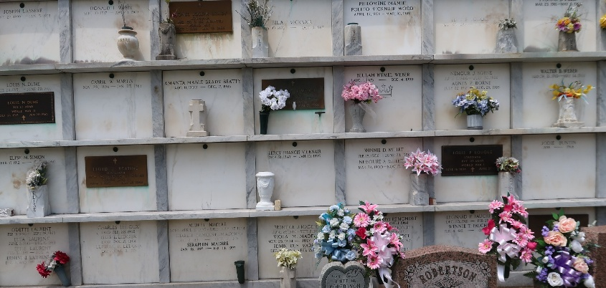

Audrey Mae Terrio passed away on Saturday, March 12, 2022 at the age of 84. A native of LaPlace, Louisiana and a lifelong resident of Reserve, Louisiana.
Loving wife to Alvin Joseph Terrio, Jr. for over 65 years, mother of Kent Terrio (Gerri), Dana Vicknair (James), Kelly Bailey (Joseph), Ron Terrio (Cindy), and Brad Terrio (Tonya); grandmother of Brandon (Teresa), Billy (Stephanie) and Blake Terrio, Chase Ferguson, Dillon Vicknair, Hali, and Heather Gautreaux (Matthew), Katie Millet (Todd), Karli Ohlenforst (Eric), Kara Poche (Phillip), and Kassidy Terrio, Emily Terrio and Hayley Guzman, great-grandmother to Brady Brown, Jaxon Terrio, Jake Terrio, Nicholas Holmes III, Natalie Holmes, Kade Coburn, and two on the way, daughter to the late Felix and Myrtle Champagne Simoneaux, sister of Carey Simoneaux, Perry Simoneaux, Myra Simoneaux, and the late Myrtle Robichaux, and Loretta Simoneaux. Survived by numerous cousins, nieces and nephews.
Relatives and friends are invited to attend the Visitation and Funeral Mass on Thursday, March 17, 2022 from 9:00 am to 11:00 am at St. Peter Catholic Church,1550 LA-44, Reserve, LA. Mass of Christian Burial will begin at 11:00 am. Burial will immediately follow the service at St. Peter Catholic Cemetery.
In lieu of flowers, the family will like masses to be held in her name.
Rose Lynn Funeral Home, Lutcher, Louisiana

