Brenda (Edler) Terrio
December 10, 1942 – October 1, 2009

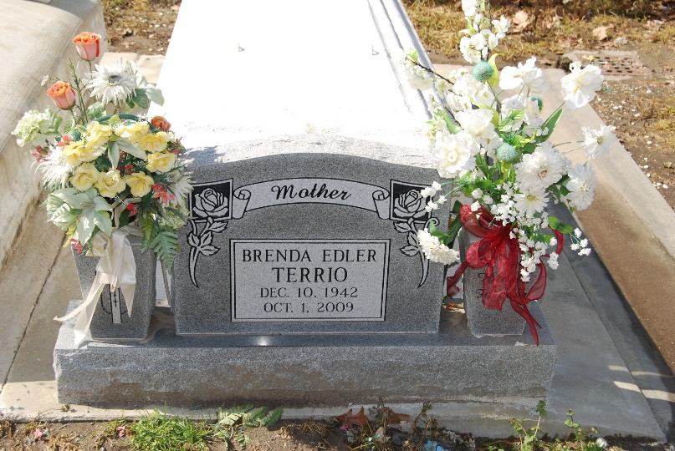
Photo by Kerry Keller

Brenda Edler Terrio on Thursday, October 1, 2009 at 11:05 am.

Beloved mother of Rodney Terrio and wife Beverly and Ritchie Terrio and Wife Blythe. Grandmother of Ryan, Ritchie Jr. and Taylor Terrio. Daughter of the late Lionel and Edeze Edler. Sister of Carol Montz and the late Lionel (Pickle) Edler Jr. Age 66. A native of LaPlace, LA and a resident of Reserve, LA.

Relatives and friends are invited to attend services. Visitation at St. Peter Catholic Church, Reserve on Saturday October 3, 2009 from 8:30 am to 10:00 am. Followed by a Mass at 10:00 am. Burial in St. Peter Cemetery. Arrangements by Millet-Guidry Funeral Home, LaPlace, La.
The Times-Picayune, New Orleans, Louisiana
Oct. 2, 2009

