Larry Clement Terrio
May 26, 1916 – April 30, 2012

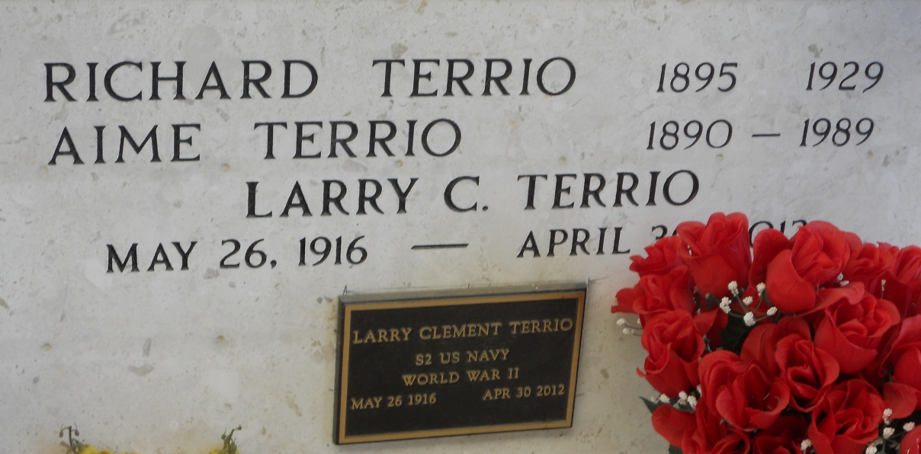
Photo by Team T-Lo

Larry C. Terrio passed away on Monday April 30, 2012.
Beloved husband of Rosalie Cancienne Terrio. Father of Jimmy (Linda), Charles (Cathy), Donald and Chris Terrio (Debbie), Dianne Compos (Jose) and Lillian LeBlanc (Joseph). Also 14 grandchildren and 15 great-grandchildren. Son of the late Richard and Aimie Terrio. Brother of Alice Triche and the late Alvin and Alotn Terrio, and Elma Falgoust. Age 95. A native of Dutchtown, LA and a resident of Reserve, LA.
Relatives and friends are invited to attend services. Visitation at St. Peter Catholic Church, Reserve, LA on Wednesday May 2, 2012 from 8:30 am to 11:00 am, followed by Mass at 11:00 am. Burial in St. Peter Cemetery. Arrangements by Millet-Guidry Funeral Home, LaPlace, LA.
The Times-Picayune, New Orleans, Louisiana
April 30-May 1, 2012

