Richard Paul Terrio
September 17, 1892 – March 28, 1921

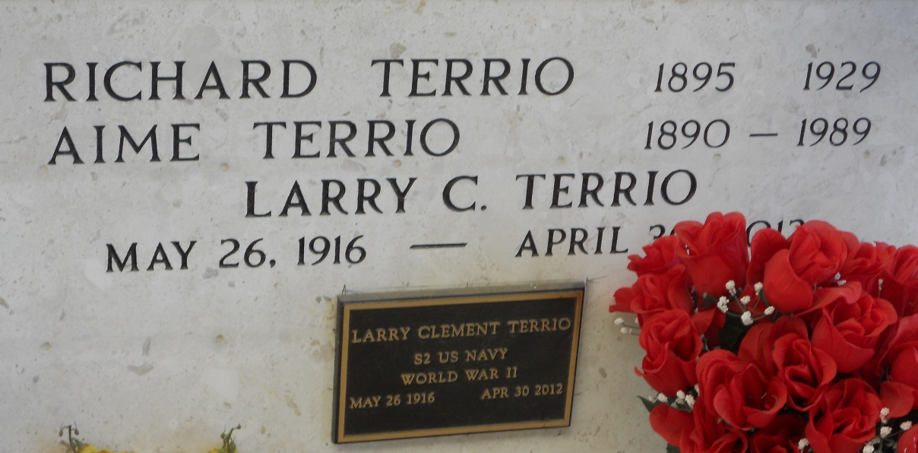
Photo by Team T-Lo

Note: birth and death dates do NOT match stone

U.S., World War I Draft Registration Cards, 1917-1918

Name Paul Richard Terrio
Race Caucasian (White)
Marital Status Married w/ 4 children
Birth Date 17 Sep 1892
Birth Place Darrow, Louisiana, USA
Residence Date 1917-1918
Street Address Dutchtown
Residence Place Ascension County, Louisiana, USA
Physical Build Medium; Height Medium
Hair Color Black; Eye Color Blue
*

Paul Richard THERIOT, son of Louis Aristide THERIOT & Alice PERTUIS, born 17 Sep 1892, baptized (illegible). Sponsors: Ernest THERIOT & Victoire MARCHAND (ASC-20, 292).

Diocese of Baton Rouge, Catholic Church Records, vol. 19, 1892-1894 (Diocese, Baton Rouge, 2003), p. 628.
*

Richard died at the age of 26 in New Orleans, from injuries received in an industrial accident at the Island Refinery, Good Hope, St. Charles Parish, LA. He was buried in Cornerview cemetery, Ascension Parish, LA. After hurricane Betsy in 1965, his remains were moved in 1966 to St. Peter's cemetery in Reserve, LA, and placed in the mausoleum.

Shirley Cassagne Terrio, "Genealogy of Oliver Terrio," orig. in LES VOYAGEURS, vol. I, no. 4.
*

New Orleans, Louisiana, U.S., Death Records Index, 1804-1949

Name Richard Paul Terrio
Gender Male
Age 26
Birth Year abt 1895
Death Date 28 Mar 1921
Death Place Orleans, Louisiana, USA
Volume Number 181
Page number 548

