Eldon Marcel Theard
October 1, 1945 – May 15, 2021

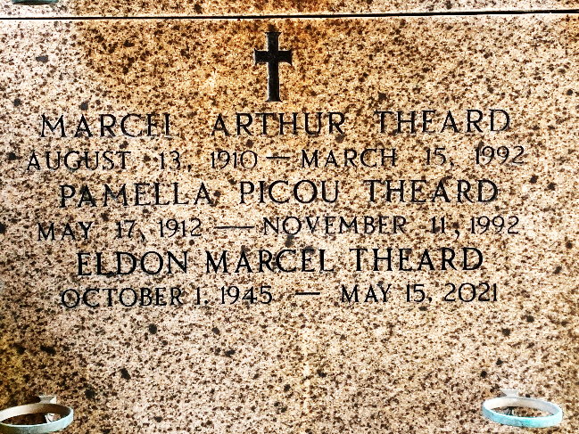
Photo by Team T-Lo

Eldon Marcel Theard of Baton Rouge passed away at the age of 75 on May 15, 2021. He was born October 1, 1945 in New Orleans, LA to Pamella Picou Theard and Marcel Arthur Theard. He was a past resident of Vidalia, New Iberia and Reserve. His biggest enjoyment outside family was attending The Arc Baton Rouge and St. John Arc.
Eldon was preceded in death by his parents, aunts Helen L. Picou, Faye Theard Foret, Hilda Theard and uncle Eldon D. Theard.
He is survived by his sister Karen Theard Ourso (the late Tom) and brother Kenneth A. Theard (Connie) both of Baton Rouge, and his aunt Curtis Theard Alexander (Lloyd) of Luling. Also survived by his nieces and nephews, Meghan Theard Vakulskas (Todd) of Atlanta, Austin Theard (Katie) of North Carolina, Kori Theard Telich (Mike) of Baton Rouge, and Blaise Theard (Sara) of Lake Charles.
A Graveside Service was held on Wednesday, May 26, 2021 with Father John Marse at St. Peter Cemetery in Reserve, LA.
Millet-Guidry Funeral Home, LaPlace, Louisiana
May 27, 2021

