Marcel Arthur Theard
August 13, 1910 – March 15, 1992

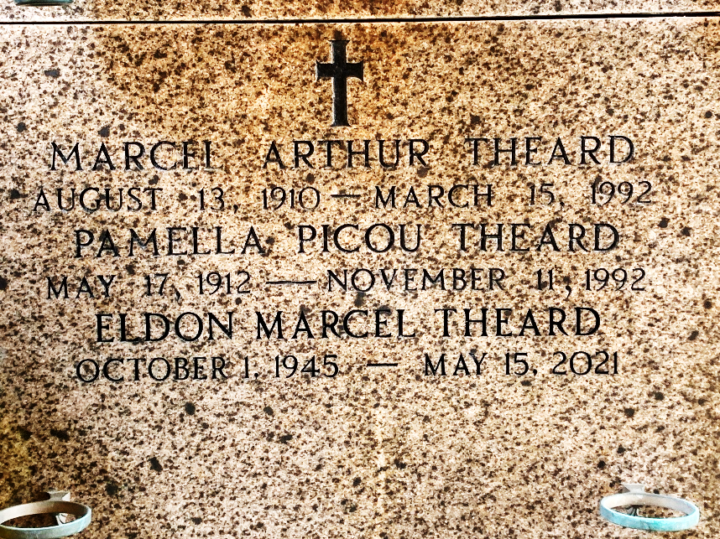
Photo by Team T-Lo

Age 81 years, a native of New Orleans, a past resident of Reserve, Louisiana, and a resident of Baton Rouge.

Husband of Pamella Picou and father of Karen Theard Ourso, Eldon and Kenneth Foret. He was the brother of Hilda Theard, Mrs. Lloyd (Curtis) Alexander and the late Mrs. James (Fay) Foret and Eldon Theard.

Services were Tuesday 17 Mar 1992 at St Peter Church, Reserve, Louisiana, with interment in St Peter Cemetery.
From Obituary, The Advocate, Baton Rouge, Louisiana
17 Mar 1992

