Charles Gratien Thibodaux III
December 22, 1943 – January 3, 2017

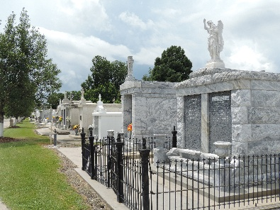

SAVANNAH - Charles G. ‘Tibby’ Thibodaux III, 70, died Tuesday, January 3, 2017, at his home, surrounded by his loving family. A native of Reserve, LA, he had lived in Savannah for the past fifteen years.
Tibby's passions were golf, his family, and all things Cajun. He was past Senior Champion at WIC and past City Amateur Senior Champion. He was retired from Chatham Steel.
Surviving are his wife, Nancy Brown Thibodaux; his daughters, Ashley Dabney Thibodaux-Jones (Chris), Emily Dupuy Thibodaux (Jon Yurick), and Courtney Louise Brown; his sisters, Shirley Locasio, and Charlene Tregre (Sue Simons); a brother, Randolph E. P. Thibodaux (Lois); 2 granddaughters, Jane Elizabeth Yurick and Kathryn Fontaine Yurick; his beloved Maxwell; his brother by another mother, Gary Morelli (Lee); and many nieces, nephews, friends, and other family members.
He was preceded in death by his parents, Charles G. Thibodaux II and Yolanda Vicknair Thibodaux.
There will be a Celebration of Charlie's Life at 4:00 PM on Saturday, January 14, 2017, at the family residence.
In lieu of flowers the family suggests remembrances to Hospice Savannah, Inc., P.O. Box 13190, Savannah, GA 31416 or the Humane Society for Greater Savannah, 7215 Sallie Mood Dr., Savannah, GA 31406.

Savannah Morning News, Georgia
Jan. 5, 2017

