Yolande (Vicknair) Thibodaux
May 18, 1912 – March 30, 2008

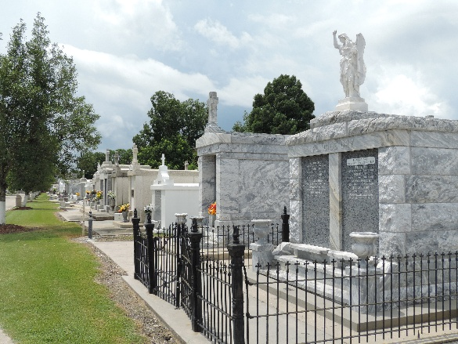

Yolande (Mena) Vicknair Thibodaux, departed this life on Sunday, March 30, 2008 at the age of 95. She was the beloved wife of the late Charles G. Thibodaux, II. Loving mother of Shirley T. Locascio, Charlene T. Tregre, Charles G. Thibodaux, III, and Randolph E. P. (Lois) Thibodaux.
She was known as Honey to her grandchildren: Dominick H. (Florence) Locascio, Jr., Yolande L. (Donald) Hull, N. Scott Tregre, Ashley T. (Chris) Jones, Emily T. (Jon) Yurick, Randolph [RET] (Stacey), Jr., Tara, Keith (Meghan), and Paul Thibodaux and her great grandchildren Olivia, Nicholas, and Ashton Locascio, Dominique Hull, Colin M. Tregre, Jane and Catherine Yurick, Aliyah, Keith, Jr. and Kylee Thibodaux and her step granddaughter Alyssa. Mena is survived by 3 sisters, Edna V. Reine, Ruth V. Buckner and Miriam V. (Kermit) Hymel.
She was preceded in death by her parents Edward and Aurora Vicknair, siblings Edward Vicknair, Jr., Lesian Waguespack, Lucille Landry, Dorothy Marchand, Berrenise Madere, Ruby Binnings and Audrey Borne and her grandsons Charles A. Locascio and Russ P. Tregre. She is also survived by a number of nieces and nephews.
Yolande was born in Reserve, LA and resided at Metairie Manor for the past 22 years. Honey was loved by everyone and will be sadly missed by all who knew her. She will be best remembered sitting at her sewing machine or crocheting, making beautiful creations or waiting tables at the old Roussell Restaurant in LaPlace. She was an honorary member of the Pontchartrain Lions Club.
The family would like to thank Journey Hospice and Waldon Health Care for all of their support.
Relatives and friends are invited to attend the Memorial Mass at Garden of Memories Funeral Home on Wednesday, April 2, 2008 at 1:30 PM. Visitation on Wednesday, April 2, 2008 from 10:00 AM until funeral time. Interment will be private. In lieu of flowers, donations can be made in memory of Yolande, to St. Peter's Catholic Church, Reserve, LA.

The Times-Picayune, New Orleans, Louisiana
April 1, 2008

