Alice Rose (Williams) Thomas
March 9, 1954 – February 20, 2010

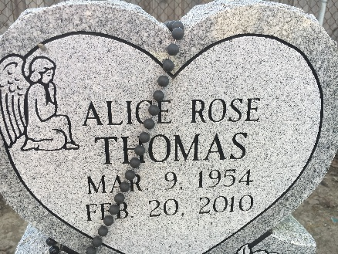
Photo by Team T-Lo

Alice Rose Williams Thomas entered into eternal rest on Saturday, February 20, 2010. She was 55 years old.
Beloved wife of Michael Thomas, Sr. Mother to Nicole Thomas, Courtney Thomas Bluain and Michael Thomas, Jr. Grandmother of Jaden Michael Thomas. Alice was a native of Montz, LA and a lifelong resident of LaPlace, LA.
She is the daughter of Ethel Mae Jenkins Williams and the late Hilton A. Williams, Sr. Extended daughter of the late Jerome Sr. and Irma Eugene. Sister to Joyce Turner, Bertha Alderson, Sedonia Johnson, Claudette Zeno, Joseph Lee Williams and Hilton Williams, Jr. Extended sister to Julia Taylor, Barbara Dunn, Robert Eugene, Jerome Eugene, Jr., and Winton Eugene. Survived by a host of aunts, uncles, nieces, nephews, cousins, other relatives and friends.
Pastors, officers and members of New Vision Missionary Baptist Church and Providence Baptist Church #2 and employees of ADM Grain Company, St. Charles Parish Public Schools, relatives and friends are invited to attend the Funeral Services on Saturday, February 27, 2010, 11:00 am, at Providence Baptist Church #2, 152 Union Lane, Montz, LA. Visitation will begin at 9:00 am until service time. Interment at St. Peter Cemetery in Reserve, LA. SERVICED BY ROBOTTOM.

The Times-Picayune, New Orleans, Louisiana
February 26, 2010

