Tajh Michael Thomas
November 24, 1992 – June 19, 2013

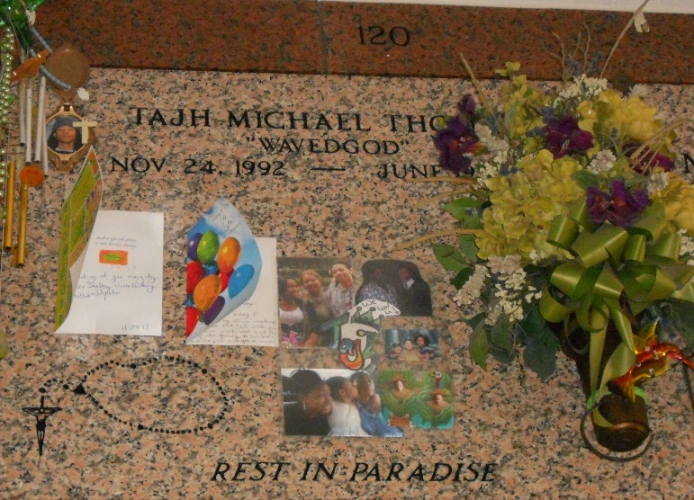
Photo by Team T-Lo

Tajh Michael Thomas on Wednesday, June 19, 2013 in Kenner, LA.

Son of Kelley Thomas Johnson and Michael Davis, Jr. Stepson of Derrick Johnson, Sr. and Danielle Johnson. Brother of Kori M. Thomas, Gyni M. Espradron and Hollis Cambre, Jr. Stepbrother of Enika, Lil Derrick, Derion, Leonard and LaDeja. Also survived by a host of aunts, uncle, cousins, other relatives and friends. Age 20 years. A native and resident of Reserve, LA.

Relatives and friends of the family, also priest and parishioners of Our Lady of Grace Catholic Church and all neighboring churches are invited to attend the Funeral Mass at Our Lady of Grace Catholic Church, 772 Highway 44, Reserve, LA on Friday, June 28, 2013 at 10:00 AM. Father Christopher Amadi, Celebrant. Interment St. Peter Cemetery, Reserve, LA. Visitation at the above named church from 8:00 AM until Mass time. SERVICED BY ROBOTTOM.

The Times-Picayune, New Orleans, Louisiana
June 25-26, 2013
**

KENNER, La. Kenner Police have identified the man found murdered in the Sugar Mill apartments as 20-year-old Tajh Michael Thomas, authorities said Thursday.
Although Thomas is from LaPlace, police said he was living at the Sugar Mill apartments with his 20-year-old cousin Trey Perrilloux. Authorities arrested Perrilloux when he tried to flee from officers upon his return to the apartment.

WWLTV.com
June 20, 2013

