Joseph B. Thompson III
August 30, 1960 – January 31, 2013

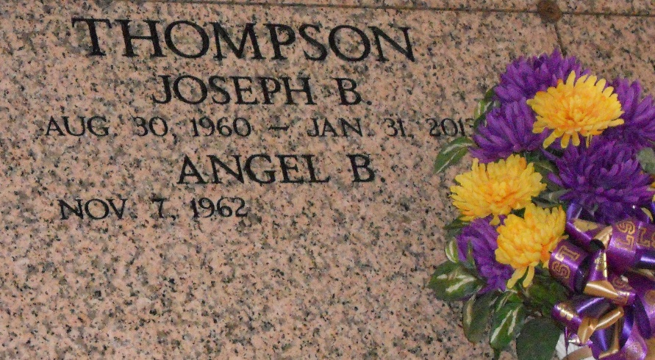
Photo by Team T-Lo

JOSEPH B. THOMPSON III passed away on Thursday, January 31, 2013 at 8:58 AM at Ochsner Hospital in New Orleans, LA. He was born in Lutcher and lived in Reserve, LA. for the past 31 years. At the age of 52, Joe is no longer suffering but is with our Heavenly Father in heaven.
He worked at NAPA in Reserve where he enjoyed meeting and talking to customers and friends for the past 30 years until he became sick with a rare form of vasculitis that took him away from us.
He was the beloved husband of Angel Brady Thompson and loving father of Colby and Shelby Thompson; son of Patricia "Pat" Bourgeois Thompson and the late Joseph B. Thompson II, and son-in-law of Armand and Rosalyn "Totsy" Brady; brother of Donna LeBlanc; Debora Thompson (Randy Landeche); Michael "Mike" LeBlanc (Bridget); Patrick "Beatle" Thompson
(Lisa); Doreen "Tutti" Perilloux (Ronnie); and brother-in-law of Jamie and Shantele Brady; godfather of Heather Mayes and Jade Brady. He is also survived by several nieces and nephews and his beloved dog, Heath.
Relatives and friends of the family are invited to attend funeral services at St. Peter's Church in Reserve, LA. on Monday, Feb. 4, 2013. Visitation will be on Sunday, Feb. 3 from 5 to 9 p.m. at Millet-Guidry Funeral Home,2806 W. Airline Hwy. in Reserve, and again on Monday at 10 a.m. in St. Peter Church before the funeral Mass at 11 a.m. Interment will be in St. Peter Cemetery.
In lieu of flowers, donations may be made to the American Kidney Fund, 11921 Rockville Pike, Suite 300, Rockville, MD 20852 or through their website at www.kidneyfund.org to make a memorial donation.
We would like to thank his second family and friends at DaVita Dialysis Center in LaPlace, LA, who took such great care of him during his illness.

The Times-Picayune, New Orleans, Louisiana
February 1, 2013

