Frances Mae (Cortez) Toland
December 18, 1939 – April 25, 2023

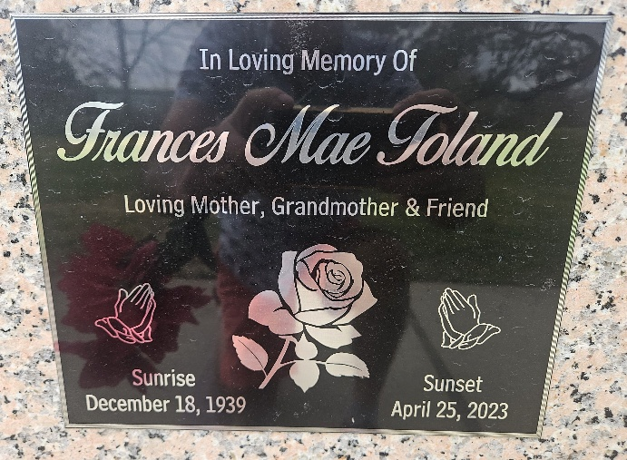
Photo by Team T-Lo

Frances Mae Toland a lifelong resident of St. John Parish passed away on Tuesday, April 25, 2023, at the of 84 years old.
Beloved mom of Michelle Cox, Jeffrey Falgoust (Hope), and the late Tyler Falgoust. Grandmother of Brooke Trosclair (Joseph), Cody Falgoust, Julien Falgoust, Tyler Falgoust, Jr., Shane Falgoust (Alida), Bri Schilling (Jordan), Darbi Lobell (Justin), and Jacob Falgoust. Great-grandmother of 11 and great-great- grandmother of one.
Daughter of the late Victor Cortez, Sr. and Aurelie Cortez. Sister of Herbert Cortez, Evelyn Songy, Victor Cortez, Jr. and the late Juliette Michel, Vickey Donnelly, Richard "Sonny" Cortez, and Barbara Cortez. Also survived by numerous nieces, nephews, and cousins.
Relatives and friends are invited to attend the Memorial Service and Visitation at Millet-Guidry Funeral Home, 2806 W. Airline Highway, LaPlace, LA., on Friday, May 5th, 2023. Visitation from 9:00 a.m. to 11:00 a.m. followed by a Memorial Service at 11:00 a.m. Entombment to follow the services at St. Peter Cemetery.

Millet-Guidry Funeral Home, LaPlace, Louisiana
April 28, 2023

