Clarence John Torres
January 30, 1927 – May 23, 1974

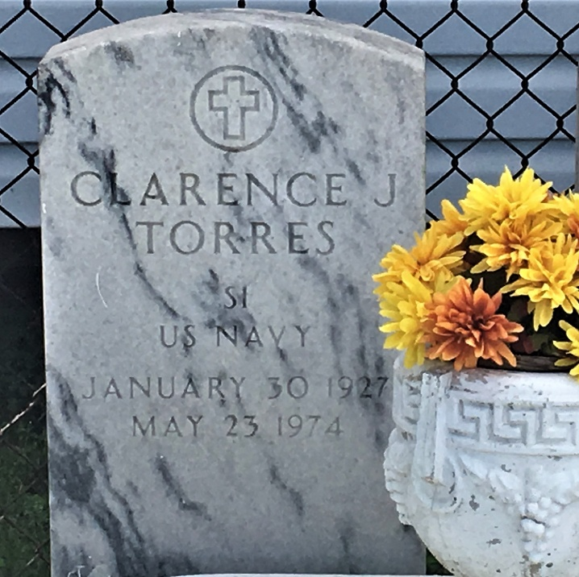
Photo by Team T-Lo

Clarence John Torres, of Garyville, LA on Thursday, May 23, 1974, at 7:29 o'clock p.m. Father of Mrs. Chris (Terry) Jouty of LaPlace, LA and Stacy Torres of Garyville, LA and the late Leslie Torres and Clarence J. Torres, Jr. Son of Mrs. Myrtle Rome Torres and the late Clarence L. Torres. Brother of Lois Mae James of Chalmette, LA, Gloria Loupe of Garyville, LA, Elaine Bergeron of Texas, Mary Ann Marse of Garyville, LA, Warren J. Torres of Garyville, LA, Lawrence Torres of Harahan, LA, Leonard Torres of Tickfaw, LA and Stuart Torres of LaPlace, LA, also survived by 1 grandson, Christopher M. Jouty. Age 47 years, a native and resident of Garyville, LA.

Relatives and friends of the family are invited to attend the funeral. Services from Millet Funeral Home, Reserve on Saturday, May 25, 1974, at 1:30 o'clock p.m. religious services at St. Hubert Catholic Church, Garyville, LA at 2:00 o'clock p.m. Interment St. Peter Cemetery, Reserve, LA. Friends may call from 5 p.m. until 11 p.m. Friday and from 8 a.m. until funeral services Saturday.

Unknown source

