Clarence Louis Torres
January 13, 1902 – February 2, 1967

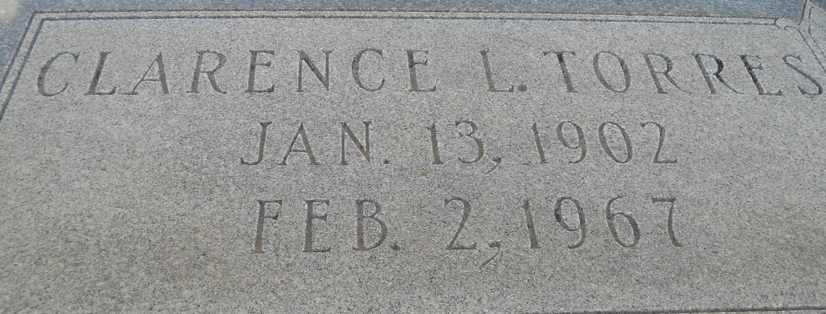
Photo by Team T-Lo

On Thursday, February 2, 1967, at 7 o'clock a.m., CLARENCE L. TORRES, beloved husband of Myrtle Rome, father of Warren, C.J. and Mrs. Clarence Marse of Garyville, LA, Mrs. Herbert James of Chalmette, LA, Lawrence Torres of Little Farms, LA, Mrs. Gaston P. Bergeron of Norco, LA, Leonard Torres of Hammond, LA, Mrs. Alvin Loupe of San Juan, Puerto Rico, Stuart Torres, U.S. Navy, and the late Shirley Paul Torres.

Son of the late Mr. and Mrs. Prudence Torres of Garyville, LA, brother of Prudence and Charles Torres, both of Norco, LA, and Mrs. Eugene Troxclair of Garyville, LA, and the late Wilson and Murphy Torres, Mrs. Orphe Landry and Mrs. Maurice Landry, also survived by 32 grandchildren, age 65, a native of Vacherie, LA and a resident of Garyville, LA.

Relatives and friends of the family are invited to attend the funeral. Services from Millet Funeral Home, Reserve, LA, on Saturday, February 4, 1967 at 11:00 o'clock a.m. Religious services at St. Hubert Church, Garyville, LA at 11:30 o'clock a.m. Interment in St. Peter Cemetery, Reserve, LA.

Unknown source

