Donald J. Torres Jr.
July 21, 1967 – January 13, 2015

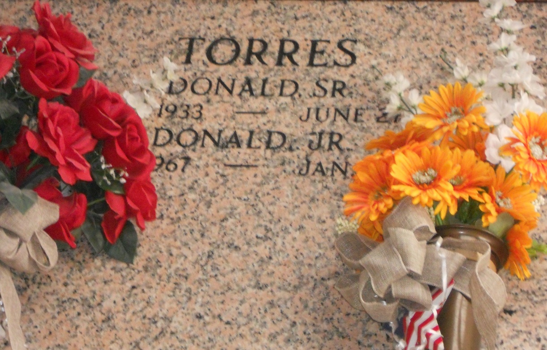
Photo by Team T-Lo

Donald J. Torres, Jr. passed away on Tuesday, January, 13, 2015 at the age of 47. He was born in Lutcher, longtime resident of Garyville and a resident of Thibodaux for the last 30 years.

Beloved son of Sandra M. Torres and the late Donald J. Torres, Sr. Brother of Donna T. Zeringue (Ray, Jr.) and Dawn T. Trosclair (Garrette). Also survived by many aunts, cousins, nieces and nephews.

Relatives and friends of the family are invited to attend the Funeral Mass at St. Hubert Catholic Church, 176 Anthony Monica St., Garyville on Friday, January 16, 2015 at 11:00 a.m. Visitation will begin in church at 9:00 a.m. Interment in St. Peter Cemetery.

The New Orleans Advocate, Louisiana
Jan. 14 to Jan. 16, 2015

