Donald J. Torres Sr.
September 16, 1933 – June 27, 2011

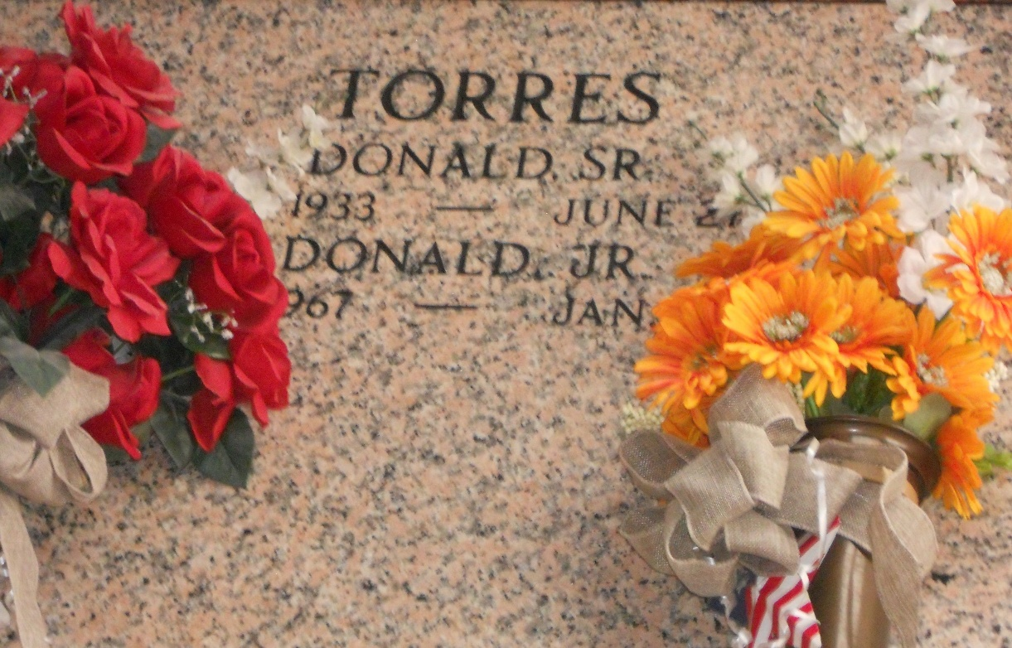
Photo by Team T-Lo

Donald Torres, Sr. passed away on Monday June 27, 2011.

Beloved husband of Sandra Marquette Torres. Father of Donna T. Zeringue (Ray), Dawn T. Trosclair (Garrette) and Donald Torres Jr. Also survived by 11 grandchildren (preceded in death by 4) and 3 great-grandchildren. Age 77. A native and resident of Grayville, LA.

Relatives and friends are invited to attend services. Visitation at St. Hubert Catholic Church, Garyville, LA on Thursday, June 30, 2011 from 9:00 am to 11:00 am followed by Mass at 11:00 am. Burial in St. Peter Cemetery, Reserve, LA. Arrangements by Millet-Guidry Funeral Home, LaPlace, LA.

The Times-Picayune, New Orleans, Louisiana
June 29, 2011

