Ellis Joseph Torres
August 14, 1934 – October 14, 2023

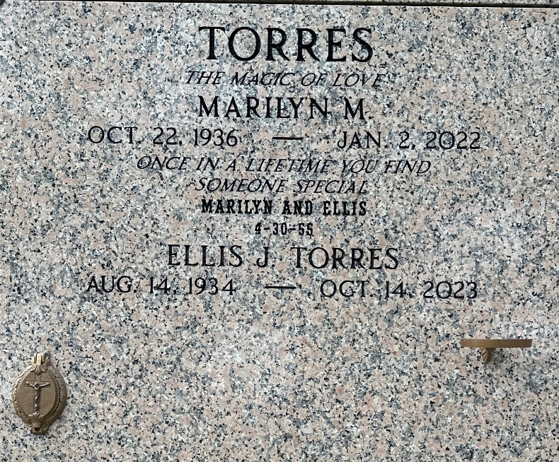
Photo by Team T-Lo

Ellis Joseph Torres passed peacefully to his eternal home on Saturday, October 14, 2023 at the age of 89. He was a native of New Orleans, LA and a resident of LaPlace, LA.
He was the beloved husband of the late Marilyn Marcelle Torres for 66 years. Loving father of Karin Songy (Gary), Eric Torres (JoAnn), Kevin Torres (Christine), Melissa Killebrew (Robert), Dolly Forsythe (Farrel) and Vicki Torres. Grandfather of Caitlin Berni (Ryan), Christopher Songy, Devin Torres (Christina), Whitney Wilkinson (Eric), Alexandra Huber (Brian), Lindsay Johnson (Jeremiah), Caroline Roussel (Brye), Emily Gauthier (Bryon), Matthew Torres (Kayleigh), Cameron Torres (Crysta), William Torres, Wesley Killebrew (Star), Laura Killebrew (deceased), Bradley Killebrew (Chelsea), Nicholas Killebrew (Kaitlyn), Andrew Killebrew (Savannah), Ryan Forsythe (Katie), Tara Forsythe, Brooke Forsythe, Taylor Hay, Brody Hay, Jack Hay, Joshua Hay and Gabrielle Hay. Great grandfather of Benjamin Berni, Julia Berni, Bailey Torres, Layla Torres, Presley Torres, Arlo Wilkinson, Isla Wilkinson, Emmeline Huber, Brooks Huber, Leah Johnson, Jules Johnson, Levi Johnson, Skylar Roussel, Remi Roussel, Catherine Gauthier, Hartley Killebrew, Holland Killebrew, Scarlett Killebrew, Beckham Killebrew, Grayson Killebrew, Ellington Killebrew, Lucas Forsythe and Knox Forsythe. Son of the late Garnet Marie Rassat Torres and Eddie Edgar Torres. Brother of Cheryl T. Gerhardt (Bruce). Brother-in-law of Ira and Mary Ann Marcelle.
The most important things in his life were God, his faith, his family and friends and his country. He graduated from Jesuit High School in 1953 and enjoyed his yearly reunions with his fellow Blue Jays. He was a Veteran of the United States Marine Corp Reserves from 1953-1961. He was a volunteer fireman with the LaPlace Volunteer Fire Department for many years. After 33 years of dedicated service, Ellis retired from E.I. Dupont in 1992.
He touched so many lives with his kind and generous spirit. He was an inspiration and role model to his children, grandchildren and great grandchildren. He was a beloved longtime member of Ascension of Our Lord Church. He lived his faith and passed it on to his entire family by his example. He loved family gatherings, and with his wife Marilyn, hosted Thanksgiving, Christmas and St. Joseph Day dinners yearly. He was there for every event and milestone in his grandchildren's lives. Ellis loved a good party and loved to dance. A wedding or party was not complete until he took the dance floor, leading everyone to dance to his favorite dance song, Bad, Bad Leroy Brown!
Relatives and friends are invited to attend the Funeral Mass at 12:00 PM on Wednesday, October 18, 2023 at St. Peter Catholic Church, 1550 LA Hwy. 44, Reserve, LA. Visitation at the church will begin at 10 AM. Interment in St. Peter Cemetery, Reserve, LA. In lieu of flowers, donations to Children's Hospital New Orleans are appreciated. Arrangements entrusted to Millet-Guidry Funeral Home.

Millet-Guidry Funeral Home, LaPlace, Louisiana
October 16, 2023

