Robert Wayne Torres
March 6, 1949 – March 7, 2012

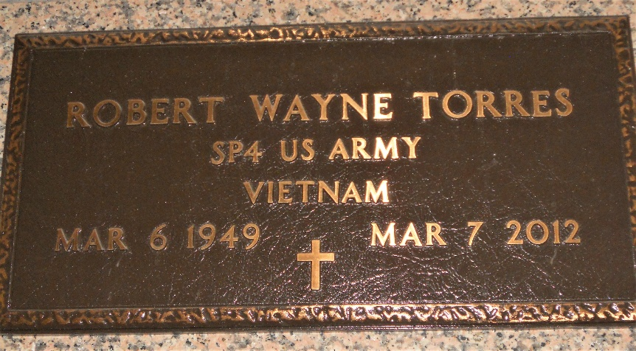
Photo by Team T-Lo

Robert W. Torres, 63, passed away Wednesday, March 7, 2012. He was the beloved husband of Trudy Bourg Torres and by first marriage of the late Mary Miano Torres, father of Teri Hebert (Robby), Wayne Vicknair Jr. (Jenni), Dodi Vicknair (Jamie) and Jenny Madere (Matt), grandfather of Ali, Alyssa, Zach Tori and Chloe.
Son of Anna Torres and the late Wilson Torres Jr. and brother of Penny Torres, Dennis Torres and the late Kevin Torres. He was a native and resident of Garyville.
Relatives and friends are invited to attend services. Visitation will be held at Millet-Guidry Funeral Home, 2806 West Airline Highway, LaPlace, on Saturday, March 10, 20212, from 8 a.m. to 9:30 a.m., followed by Mass at St. Hubert Catholic Church in Garyville at 10 a.m. Burial will follow in St. Peter Cemetery in Reserve.
In lieu of flowers, donations to the Kenny Bourg Cancer Fund at Capital One Bank are preferred.

The Times-Picayune, New Orleans, Louisiana
March 8-9, 2012

