Warren Joseph Torres Sr.
August 6, 1925 – August 3, 1995

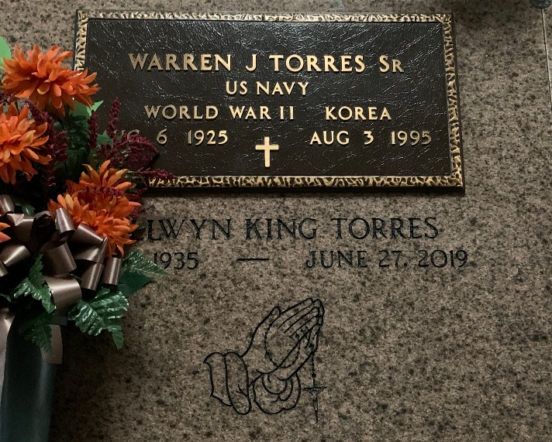
Photo by Team T-Lo

Warren J. Torres, Sr. on Thursday, August 3, 1995 at 8:00 a.m. Beloved husband of Nellwyn King Torres. Father of Connie Babin, Warren Torres, Jr., Paula LeBlanc, Susan Deroche, Brent and Lisa Torres. Father-in-law of Larry Babin, Debra Torres, Glenn LeBlanc, Richard Deroche, Jr. and Angela Torres.
Son of the late Clarence and Myrtle Rome Torres. Brother of Lawrence, Stuart and Leonard Torres, Lois James, Gloria Loupe, Elaine Bergeron, Mary Ann Marse and also the late Shirley and Clarence Torres. Also survived by 15 grandchildren.
Age 69. A native and resident of Garyville. He was Veteran of World War II and the Korean Conflict.
Relatives and friends of the family, also members and auxiliary of VFW Post 8167 are invited to attend the Funeral Services at Millet Guidry Funeral Home, 2806 West Airline Hwy., Reserve, on Saturday, August 5. Followed by Religious Services at St. Hubert Catholic Church, Garyville, at 11:00 a.m. Interment in St. Peter Cemetery, Reserve. Friends may call from 6:00 until 10:00 p.m. on Friday and from 8:00 a.m. until services on Saturday.

Unknown source

