Herman Joseph Toups Jr.
June 16, 1945 – February 28, 2009

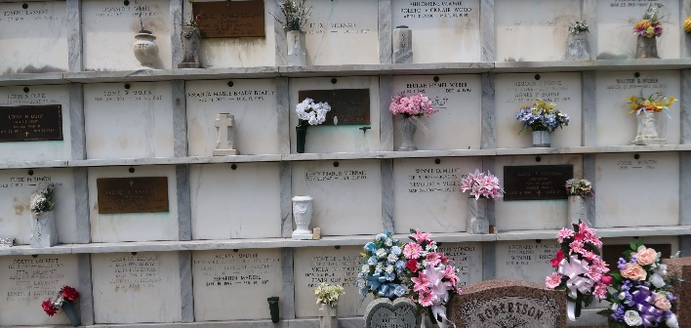

Herman J. Toups, Jr. age 63, died on Saturday February 28, 2009 at Tulane Medical Center in New Orleans, La.
He is survived by his wife, Judy Poleto Toups; daughter and son-in-law: Mary Lynn Toups Laiche and Aaron (Tutty) Laiche; and son and daughter-in-law, Herman Toups III and Celeste Hymel Toups. He was the loving grandfather of Amanda and Ali Laiche and Ashley and Jenna Toups. Brother-in-law of Allen Poleto.
Son of the late Herman J. Toups Sr. and Dorothy Louque Toups and son-in-law of the late Samuel Poleto and Bertha Amedee Poleto.
A native of Kenner, La. and a resident of Garyville, La. for the past 43 years. He worked for Kaiser Aluminum, LaRoche Chemicals and St. John Parish Sheriff's Office. He was an avid LSU fan. He will be sadly missed by wife, children and grandchildren.
Special thanks to Sue Hymel for being there in our time of need.
Relatives and friends are invited to attend services. Visitation at St. Hubert Catholic Church, Garyville, La. on Monday March 2, 2009 from 11:00 a.m. to 1:00 p.m. Followed by Religious Services at the church at 1:00 p.m. Burial in St. Peter Cemetery, Reserve, La. Arrangements by Millet-Guidry Funeral Home, LaPlace, La.

The Times-Picayune, New Orleans, Louisiana
March 1, 2009

