Alfred Benjamin Toussel
April 15, 1915 – February 10, 2002

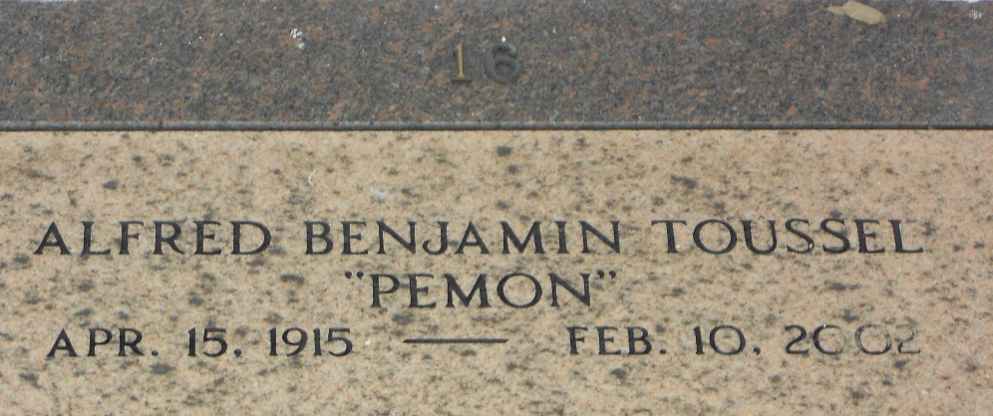
Photo by Team T-Lo

Alfred Benjamin (Pemon) Toussel, On Sunday, February 10, 2002 At 7:50 P.M.
Beloved Husband Of The Late Eunice D. Toussel. Father Of Eleanor T. Coberly, Barbara T. King And Rachel T. Rasberry.
Son Of The Late Gaston And Susanna W. Toussel. Brother Of Juanita Daigle And The Late Annie Hartsell, Harold And Eddie Toussel. Also Survived By 10 Grandchildren, 1 Deceased And 3 Great Grandchildren, 1 Deceased.
Age 86 Yeas. A Native Of Lafayette And A Resident Of Laplace For The Past 58 Years.
Relatives And Friends Of The Family Are Invited To Attend The Funeral Services At Millet-Guidry Funeral Home, 2806 W. Airline Highway On Friday, February 15, 2002 Followed By Religious Services At St. Joan Of Arc Catholic Church At 10:00 A.M. Burial In St. Peter Cemetery, Reserve. Visitation From 5:00 P.M. To 10:00 P.M. On Thursday And From 8:00 A.M. Until Services On Friday.

The Times-Picayune, New Orleans, Louisiana
February 14, 2002

