Doris (Rushing) Tramonte
January 11, 1926 – May 14, 2019

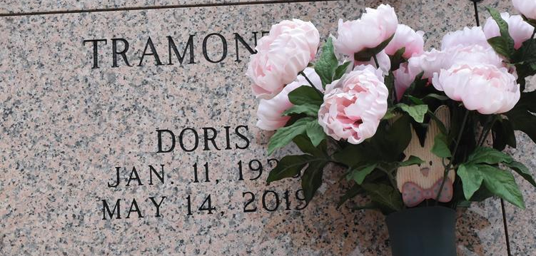

Doris Rushing Tramonte, age 93, passed away on May 14, 2019. She was a native and resident of LaPlace, LA.
She is survived by daughters, Sheila Veron (Polo), Brenda Malbrough (Dooney) and Tammy Martin (Pat); daughter-in-law, Cathy Tramonte; grandchildren, Stacy Bourgeois, Daniel Veron, Celeste Millet, Troy Malbrough, Jason Malbrough, Trent Malbrough, Devin Martin, Whitney Steib and Hayley Tramonte. Doris is also survived by 17 great-grandchildren and 2 great-great-grandchildren with one expected baby boy in July of 2019.
Doris was preceded in death by her husband, Louis Tramonte; son, Kenneth (Bubby) Tramonte; parents, Henry and Denise Rushing; brothers, Lloyd "Buck" Rushing and John "J-Boy" Rushing and one sister, Mildred "Geet" Englade.
Visitation will be on Friday May 17 ^{th} , 2019 from 6:00pm until 8:00pm at Rose Lynn Funeral Home in Lutcher, LA and on Saturday May 18 ^{th} , 2019 at St. Joan of Arc Catholic Church in LaPlace, LA from 9:00am until 10:00am. A Mass of Christian Burial will be held at 10:00am at St. Joan of Arc Catholic Church in LaPlace, LA on Saturday with burial following at St. Peter Catholic Cemetery in Reserve. LA.
The family would like to thank Mary Hotard Cancienne for all of the love and care she gave our mother. The family would also like to thank St. James Parish Hospital employees.
In lieu of flowers donations can be made in honor of Doris to Children's Hospital in New Orleans, LA and St. Jude Children's Hospital. Rose Lynn Funeral Services is in charge of the funeral arrangements.

Rose Lynn Funeral Home, Lutcher, Louisiana

