John Leopold Tregre
July 25, 1939 – September 26, 2017

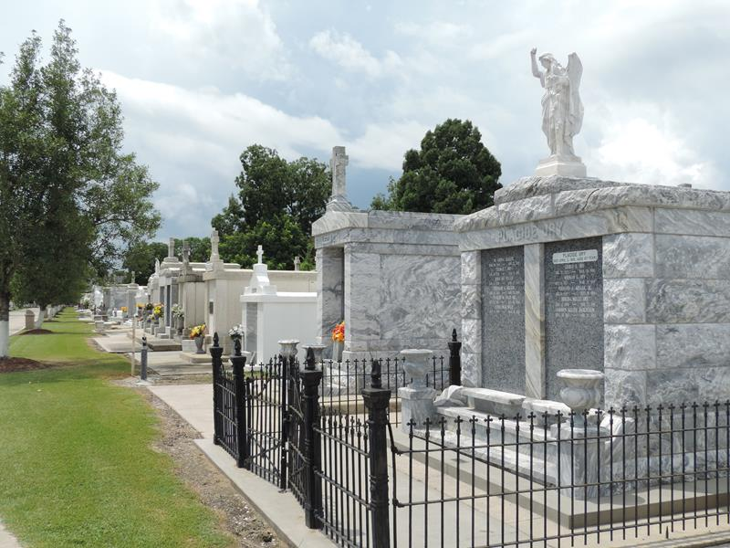

John L. Tregre passed away Sept. 26 at the age of 78. John was born July 25, 1939 in Garyville, LA, the eldest of 4 children by parents Frank Roy and Verda Williams Tregre.
John moved to Deer Park, TX in 1974 and opened Johns Frame Shop in Pasadena. During the next 30 years, John was the "Go to Guy" in Pasadena, Laponte, South Houston and Deer Park for many auto body shops, Pasadena police dept, construction companies, and customers who wrecked their cars and had fame damage.
John was known as a straight shooter, never cheated anyone, and could repair nearly anything. And if you went to his shop, you better have some time, because John sure could talk.
John is survived by his 3 children, Troy, Jonna, and John "Lee" Tregre; Grandchildren, Zachary, Kyleigh, Krista, and Hunter; Also his siblings Frank Roy (Elaine), Donald (Sara), and Marlene.
Gravesite services and internment will be Friday, November 24th at 1 pm in St. Peters Cemetery, Reserve, LA.

The Advocate, Baton Rouge, Louisiana
November 21-24, 2017

