Lucille Mae (Audiffred) Tregre
December 17, 1915 – December 24, 2011

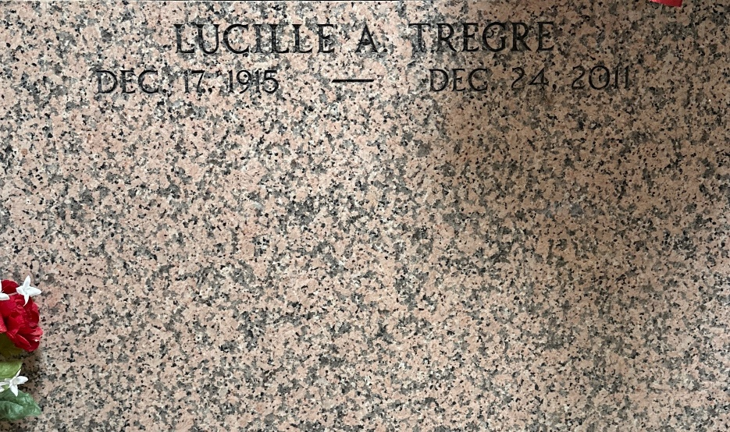
Photo by Team T-Lo

Lucille Audiffred Tregre passed away on Saturday, December 24, 2011. Beloved wife of the late Vincent Tregre. Mother of Emily Cornwell (Billy). Grandmother of Nicole, Shane and Travis Cornwell. Great grandmother of Shane and Paige Cornwell.
Special thanks to Ormond Nursing Home and Hospice Associates of Metairie. Age 96 years. A native and resident of Reserve, LA.
Relatives and friends are invited to attend services. Visitation at Millet-Guidry Funeral Home, 2806 W. Airline Hwy, LaPlace, LA on Wednesday, December 28, 2011 from 11:30AM until 12:45PM, followed by a Mass at St. Peter Catholic Church, Reserve at 1:00PM. Burial in church Cemetery.

The Times-Picayune, New Orleans, Louisiana
December 26-27, 2011

