Olympe (Williams) Tregre
March 24, 1874 – December 6, 1944

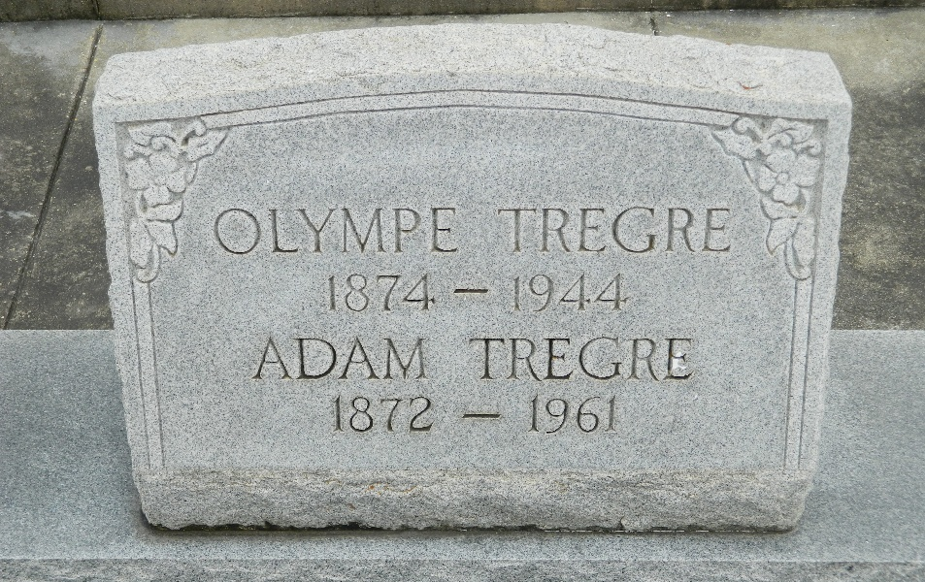

Olympe Williams, wife of Leonce "Boy" Tregre died at Lutcher, Louisiana, on Wednesday 5 Dec 1944 at 2:10 p.m. at age 72 years.

She was the mother of Mrs. Aline Hebert, Mrs. C. J. Spatz, Mrs. John Haydel, Peter Tregre and the late Elmore Tregre. Also survived by 15 grandchildren and 4 great-grandchildren.

Services were Thursday, 7 Dec 1944 at St Peter Church, Reserve, Louisiana, with interment in St Peter Cemetery, Reserve.

The Times-Picayune, New Orleans, Louisiana
7 Dec 1944

