Rose (Stein) Tregre
October 30, 1927 – February 28, 2016

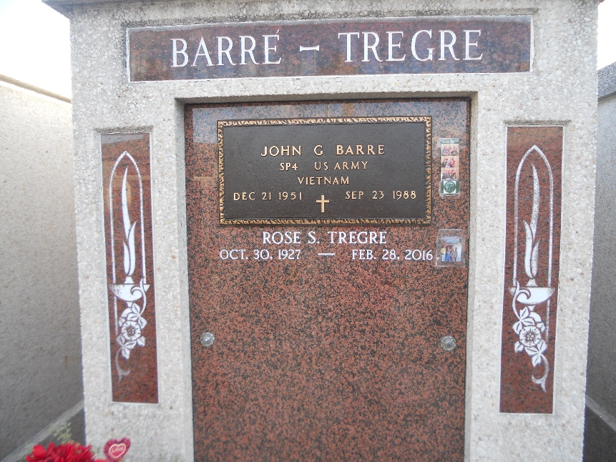
Photo by Team T-Lo

Rose Stein Tregre passed away on Sunday, February 28, 2016. She was 88, a native of Lions, LA and a resident of Reserve, LA.
Beloved wife of Peter Tregre, Jr. Mother of Kathy Oncale (Stephen), Tim Tregre (Darnell) and Nanette Kunkel (John).
Daughter of the late Ida Michel and Louis Stein. Sister of Malcolm Stein (Margaret), Annabelle Ockman (the late Norman), Linda Madere (Kenneth), Ronnie Kesler (Bill) and the late Joseph Stein. Also survived by 7 grandchild-ren and 12 great-grandchildren.
She was preceded in death by a grandchild, a great-grandchild, a daughter-in-law and a son-in-law.
Relatives and friends are invited to attend the Funeral. A Funeral Mass will be celebrated in St. Peter Catholic Church, 1550 Hwy 44, Reserve, LA on Thursday, March 3, 2016 at 11:00 a.m. Visitation at the church from 9:00 a.m. until 11:00 a.m. Interment in St. Peter Cemetery. Arrangements by
Millet-Guidry Funeral Home.
TheAdvocate.com from Feb. 29 to Mar. 3, 2016

