Viola (Sorapuru) Tregre
1895 – May 1993

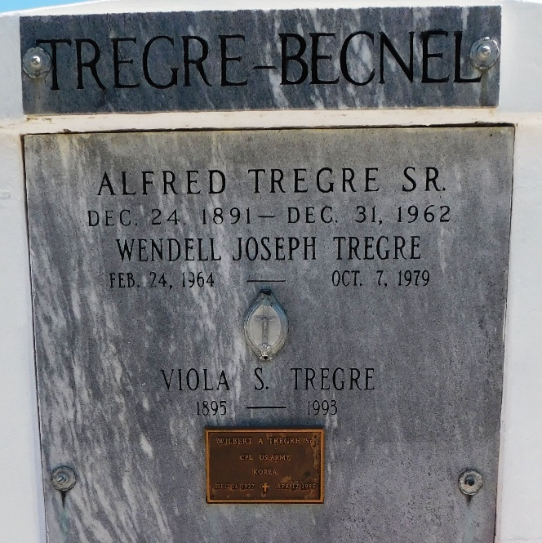
Photo by Mary Agnes Hammett

Viola Sorapuru Tregre, A Homemaker, Died Friday At Fountain Manor Nursing Home In New Orleans. She Was 97. Mrs. Tregre Was Born In Lucy And Lived In Reserve For 70 Years. She Was A Member Of Knights Of Peter Claver Court 73 Ladies Auxiliary.
Survivors Include Four Sons, Hilton Tregre Of Chicago And Raymond, Wilbert And Alfred Tregre Jr.; A Daughter, Enola Becnel; Four Sisters, Rosy Peychaud, Ruby Lamothe, Aline Johnson And Neomi Bradby Of Newport News, Va.; 17 Grand-children And 22 Great-Grandchildren.

A Visitation And Mass Were Held Wednesday At Our Lady Of Grace Catholic Church In Reserve. Burial Was In St. Peter's Cemetery In Reserve.

The Times-Picayune, New Orleans, Louisiana
May 13, 1993

