Wilbert Antoine Tregre Sr.
December 16, 1927 – April 12, 1995

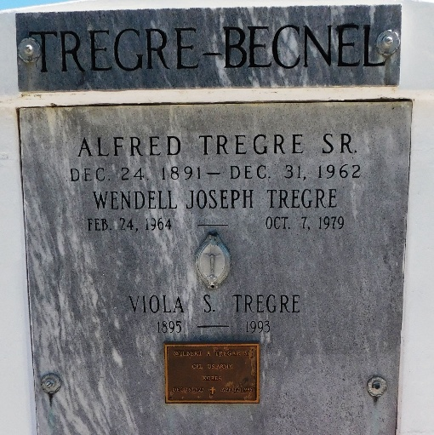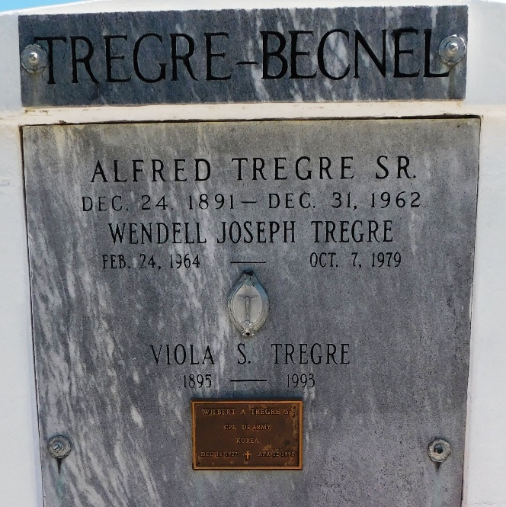
Photo by Mary Agnes Hammett

Wilbert 'Trigger' Antoine Tregre Sr., A Contractor At C.T. Boudreaux Lumber Co. In Lutcher And Belmont Lumber Co. In Heston, Died Wednesday Of Lung Cancer At His Home.
He Was 67. Mr. Tregre Was A Lifelong Resident Of Reserve. He Was A Veteran Of The Korean War. He Recently Was Honored At The Third Annual Christian Life Award Ceremony In Reserve. He Was Chaplain Of Veterans Of Foreign Wars Post 3337; A Founding Member Of The Ambassadors Social And Civic Club; A Member Of Willing Workers Of St. John Parish; Citizens United For Progress Of St. John Parish; The Brick Masons Association Of
New Orleans; The Allied Craftsmen Union, Which Honored Him After 40 Years Of Service; And Our Lady Of Grace Catholic Church, Its Building And Bingo Committees And Council.
Survivors Include His Wife, Emelda Darensbourg Tregre; Two Sons, Wilbert Antoine Tregre Jr. Of Reserve And Michael Kerry Tregre Of Laplace; Two Daughters, Miranda Ann Tregre And Lisa Tregre Wilder, Both Of New Orleans; Three Brothers- Alfred Jr. And Raymond Tregre, Both Of New Orleans, And Hilton Tregre Of Chicago; A Sister, Enola Tregre Becnel Of New Orleans; And Five Grandchildren.
A Mass Will Be Said Today At 11 A.M. At Our Lady Of Grace Catholic Church In Reserve. Visitation Will Begin At 9 A.M. Burial Will Be In St. Peter
Cemetery In Reserve.

The Times-Picayune, New Orleans, Louisiana
April 17, 1995

