Wilfred Francis Tregre Jr.
October 23, 1932 – February 4, 2012

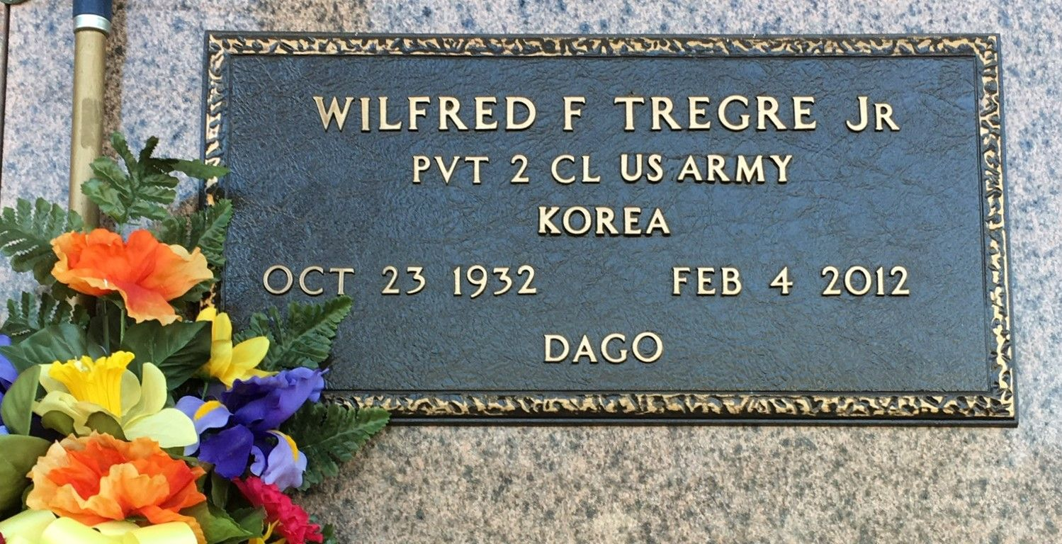
Photo by Team T-Lo

Wilfred Francis "Dago" Tregre, Jr. passed away peacefully on Saturday, February 4, 2012, at the age of 79. He was born on October 23, 1932, in St. James, Louisiana, and was a resident of Reserve, Louisiana, for all of his adult life.
He was the loving father of four sons: Steven "Dukey" Tregre (Amy) of LaPlace, Kevin "Coosie" Tregre of Reserve, Glenn "Buddie" Tregre (Tracy) of LaPlace, and Kenneth "Noonie" Tregre of Reserve. He is survived by four grandchildren: Glenn Tregre, Jr., Laura T. Breaux, Steven Tregre, Jr. and Katie Tregre, and two great-grandchildren: Shana Breaux and Taylor Tregre. He had one sister, Frances T. Torres of Norco and one brother, Irvin Tregre of Reserve. Wilfred was preceded in death by his parents, Wilfred Tregre and Clothilde Chiquet Tregre.
In 1997, he retired from Kaiser Aluminum-Gramercy with 40 years of service. Throughout his retirement, he enjoyed spending time with family and friends, gardening and raising his chickens.
Relatives and friends of the family are invited to attend services. Visitation at St. Peter Catholic Church, 1550 Hwy. 44, Reserve, Louisiana on Tuesday, February 7, 2012 from 10:00 a.m. to 12:00 p.m., followed by Mass at 12:00 p.m. Burial in St. Peter Cemetery. Arrangements by Millet-Guidry Funeral Home, LaPlace, Louisiana.

The Times-Picayune, New Orleans, Louisiana
Feb. 5 to Feb. 6, 2012

