Alice Marie (Terrio) Triche
March 20, 1919 – October 11, 2014

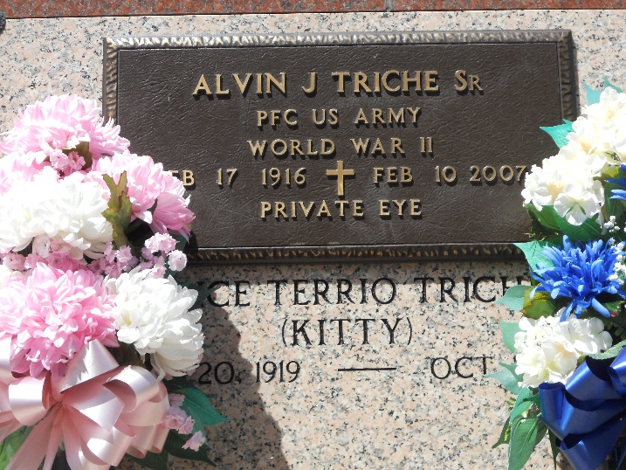
Photo by Team T-Lo

Alice Terrio Triche passed away on Saturday, October 11, 2014. She was 95, a native of Cornerview and a resident of Reserve.
Beloved wife of the late Alvin Joseph Triche, Sr.. Mother of Alvin J. Triche (Cheryl), Richard J. Triche (the late, Rogerie) and Judy Triche Haydel (Nelson). Daughter of the late Aimee Hebert Terrio and Richard Terrio. Sister of Elma Terrio Falgoust and Alvin, Larry and Alton Terrio. Grandmother of Rory, Rhonda, Chantal, Tiffany, Monique, Carlyle, Troy, Colette, Claudette and the late baby C. Triche. Also survived by 17 great-grandchildren, 9 great-great-grandchildren and many nieces and nephews.
The family would like to thank the staff at Twin Oaks Nursing Home, especially Judy, Bird and Harmony Hospice, for their care and compassion during our mother’s final year.
Relatives and friends of the family are invited to attend the funeral. A Funeral Mass will be celebrated in St. Peter Catholic Church, 1550 Hwy 44, Reserve, LA. on Wednesday, October 15, 2014 at 11:00 a.m. Visitation at the church from 9:00 a.m. until 11:00 a.m. Interment in St. Peter Cemetery.

Millet-Guidry Funeral Home, LaPlace, Louisiana

