Alvin Joseph Triche Sr.
February 17, 1916 – February 10, 2007

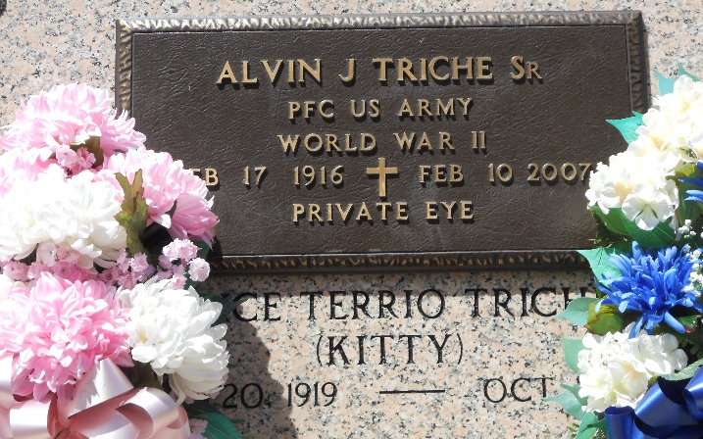
Photo by Team T-Lo

Alvin J. (Private Eye) Triche, Sr. on Saturday, February 10, 2007, at 5:10 PM.

Beloved husband of Alice Terrio Triche for 70 years. Father and father-in-law of Alvin Jr. and Cheryl Triche, Richard and the late Rogerie Triche and Judy and Nelson Haydel. Grandfather of Rory, Rhonda, Chantel, Tiffany, Monique, Carlyle, Troy, Colette and Claudette. Also survived by 17 great-grandchildren and 1 great-great-grandchild.

Son of the late Alcee and Eva Weber Triche. Brother of Henry, Lorry and Lawrence Triche and the late Paul and Roland Triche. Age 90 years. A resident of Reserve, LA.

Relatives and friends of the family, also American Legion Post 159 are invited to attend services. Visitation at St. Peter Catholic Church, Reserve, LA on Tuesday, February 13, 2007 from 11:00 AM until 1:00 PM. Followed by Religious Services at the church at 1:00 PM. Arrangements by Millet-Guidry Funeral Home, LaPlace, LA.

The Times-Picayune, New Orleans, Louisiana
Feb. 12, 2007

