Charles Joseph Triche Jr.
June 2, 1926 – November 30, 1947

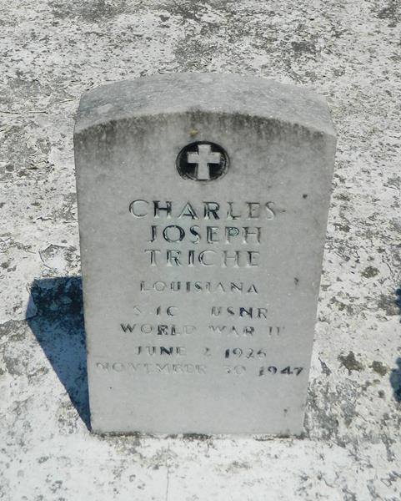

Charles Triche, Jr, age 21 years, died at Reserve, Louisiana, at 2:00 in the morning on Sunday, 30 Nov 1947. He was the sone of Antoinette Catoire and Charles Triche, Sr, and the brother of Marion, David, Warner, Gloria, Allen and Sherrian Triche. Services were Monday, 1 Dec 1947, at St Peter Church, Reserve, Louisiana, with interment in St Peter Cemetery, Reserve.

Unknown source

