Delphine Marcelline (Clement) Triche
May 16, 1850 – December 12, 1922

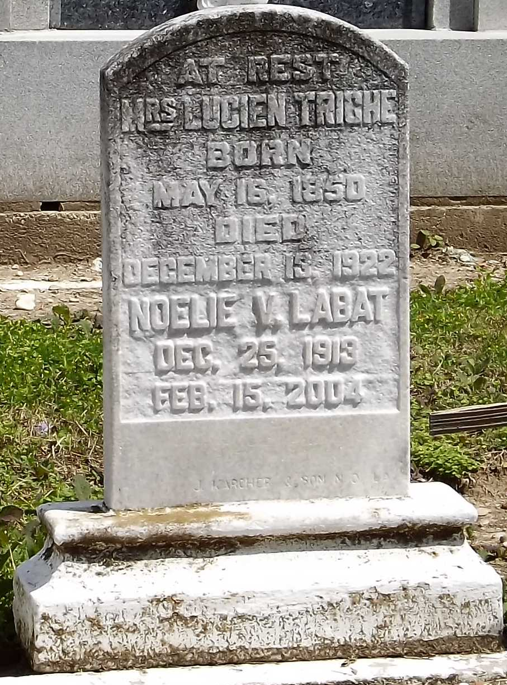
Photo by Mary Agnes Hammett

Mrs. Lucien Triche, born Delphine Clement, died Tuesday morning, 12 Dec 1922, at 9:00 o'clock in New Orleans after a lingering illness. She was 72 years old, a native of St John the Baptist Parish where she had always lived and leaves two children to mourn her demise, Mr. Paulin Triche of Laplace, Louisiana, and Mrs. Abraham Vicknair of Montz, Louisiana. The next day her body was laid to rest in the local cemetery after the funeral services were held in St Peter's Church.

L’Observateur, LaPlace, Louisiana
December 16, 1922

