Dorrel James Triche
September 8, 1937 – November 4, 2016

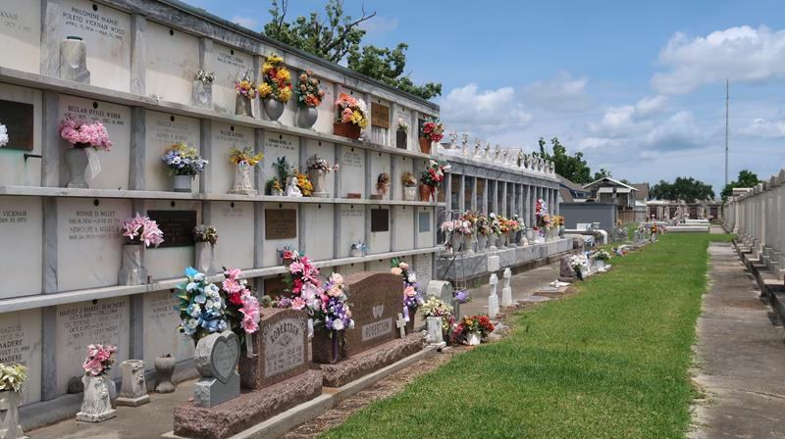

Dorrel Triche, Sr. passed away on Friday, November 4, 2016. He was 79, a native and life-long resident of LaPlace, LA.
Beloved husband of Mary Alice Lambert Triche. Loving father of Keith (Alisa), Dorrel, Jr. (Liz), Michael (Edie) Gregg (Judy) and Douglas Triche (Karen).
Son of the late Lawrence and Lena Rodrigue Triche. Brother of the late Melvin Triche (Helen).
Preceded in death by grandson Deputy Jeremy Triche. Grandfather of Jay, Angie, Bennett, Amy, Nicole, Jared, Grace, Brian, Jacob, Nathan and Jaime Triche and Jeremy Vicknair. Great-grandfather of Kade, Emma, Jackson, Jayce and Luke.
In lieu of flowers, please consider a donation in his memory to Dr. Oliver Sartor's Prostate Cancer Research Fund at Tulane Cancer Center, 1430 Tulane Ave., SL-68, New Orleans, LA 70112.
Relatives and friends are invited to attend the funeral. A Funeral Mass will be celebrated at St. Joan of Arc Catholic Church, 529 W 5th Street, LaPlace, LA on Monday, November 7, 2016 at 12:30 p.m. Visitation at the church from 9:30 a.m. until 12:30 p.m. Interment in St. Peter Cemetery, Reserve, LA. Millet-Guidry Funeral Home is in charge of services.

The New Orleans Advocate (Louisiana)
Nov. 5 to Nov. 7, 2016

