Evella Marie Triche
January 12, 1864 – March 6, 1958

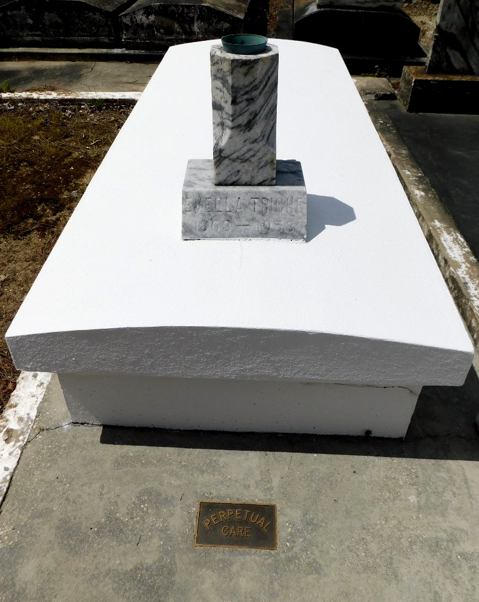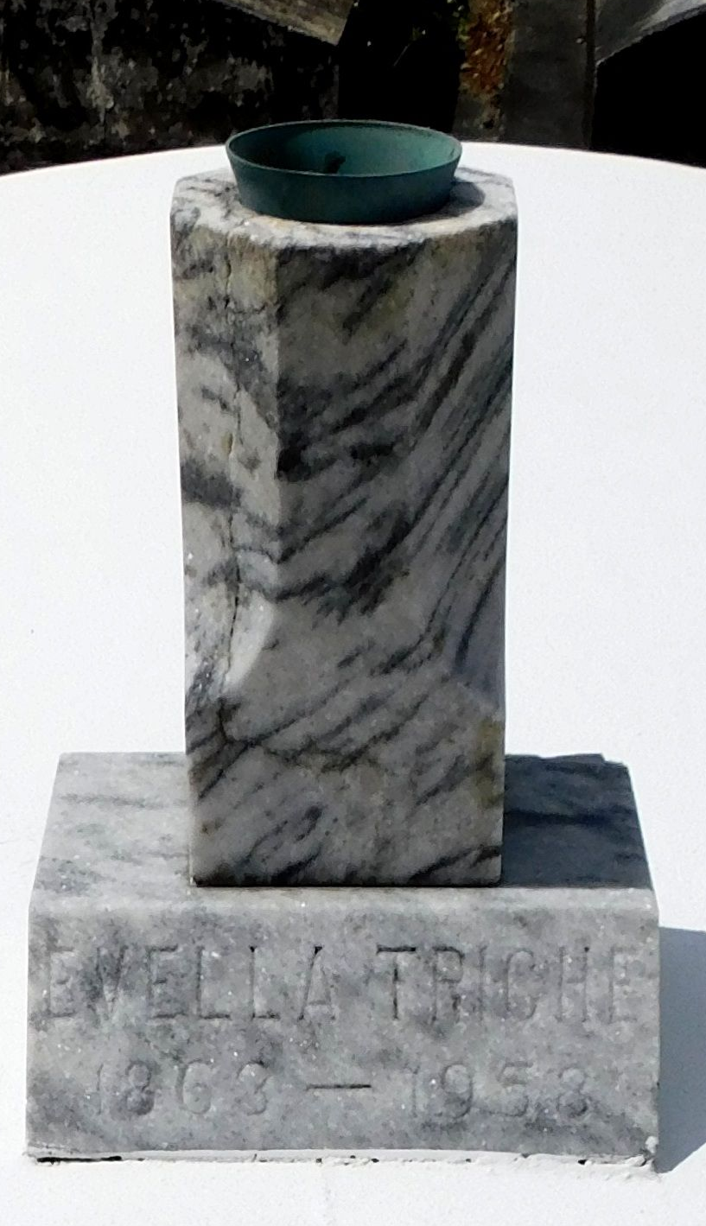
Photos by Mary Agnes Hammett

TRICHE - At the residence of her grandniece, Mrs. Maurice Triche, Reserve, La., on Thursday, March 6, 1958, at 8:15 o'clock p.m., Evella Triche, daughter of the late Adam Triche and Amelia Monier, sister of the late Edmond, Adam jr., and Marie Triche and Mrs. Louise Chapaton, age 95 years, a native and a resident of Reserve. La.

Relatives and friends of the family are invited to attend the funeral, which will take place from Millet Funeral Home, Reserve, La., on Saturday, March 8, 1958, at 10 o'clock a.m., followed by religious services at St. Peter's church, Reserve, La. Interment in St. Peter cemetery.
Unknown source

