Gerard Yvon Triche
May 15, 1904 – February 15, 1964

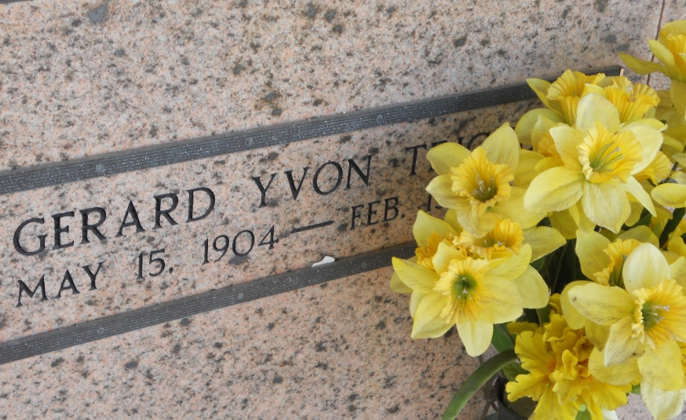
Photos by Team T-Lo

TRICHE - At St James Hospital, Lutcher, La, on Saturday, February 15, 1964, at 7 o'clock p.m., GERARD (PAT) TRICHE, beloved husband of Virginia Lambert; foster father of Paul Lambert; brother of Mrs. Odette Becnel of St. Gabriel, La, Mrs. Harry Hebert and Mrs. John Richard of Baton Rouge, La, and the late G. D., Andrew and Russel Triche and Mrs. Alcee Becnel and Lucille Triche; age 59 years; a native of Reserve, La, and a resident of Garyville, La, for the past 40 years.

Relatives and friends of the family, also the Garyville Lions Club, are invited to attend the funeral. Services from Millet Funeral Home, Reserve, La, on Monday, February 17, 1964, at 10 o'clock a.m. Religious services at St Hubert Church, Garyville, La. Interment in St Peter Mausoleum, Reserve, La.
The Times-Picayune, New Orleans, Louisiana
16 Feb 1964, p. 4

