Gloria Mae (Mabile) Triche

November 20, 1932 - November 28, 2023

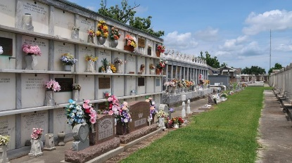

Gloria Mae Mabile Triche passed away peacefully in her home, surrounded by family on Tuesday, November 28, 2023, at the age of 91. She was a resident of Reserve, LA.
Gloria was a lifelong parishioner of St. Peter Catholic Church in Reserve. She worked as a Tour Guide at the historic San Francisco Plantation. She was the Treasurer of the Lady’s Altar Society and a member of the American Legion Ladies Auxiliary.
Beloved wife of the late Henry A. Triche. Loving mother of Mark Triche (Robin Hanna), Ronald Triche (Judy Mulkey) and Dickey Triche. Grandmother of Marcy Shewell (Wayne), Rhett Triche (Johonna), Robert Triche, and Ryan Triche. Great-grandmother of 4. Daughter of the late Leslie Lasseigne Mabile and Paul Joseph Mabile. Also survived by numerous nieces, nephews, and cousins.
Relatives and friends are invited to attend the Visitation and Funeral Mass at St. Peter Catholic Church, 1550 Hwy 44, Reserve on Friday, December 1, 2023. Visitation will be held in church from 9:00 a.m. until 11:00 a.m. with the Funeral Mass to immediately follow at 11:00 a.m. Interment in St. Peter Cemetery.
The family would like to extend thanks to Johonna, Cheyenne, Nena, Beth, and Deanie. The family would also like to extend special thanks to her niece, Judy Haydel, for the extraordinary love and support throughout Gloria’s life.
In lieu of flowers please consider a donation in her memory to St. Peter Catholic Church, Reserve, LA.

Millet-Guidry Funeral Home, LaPlace, Louisiana
November 30, 2023

