Isidore Triche
August 19, 1849 – October 27, 1925

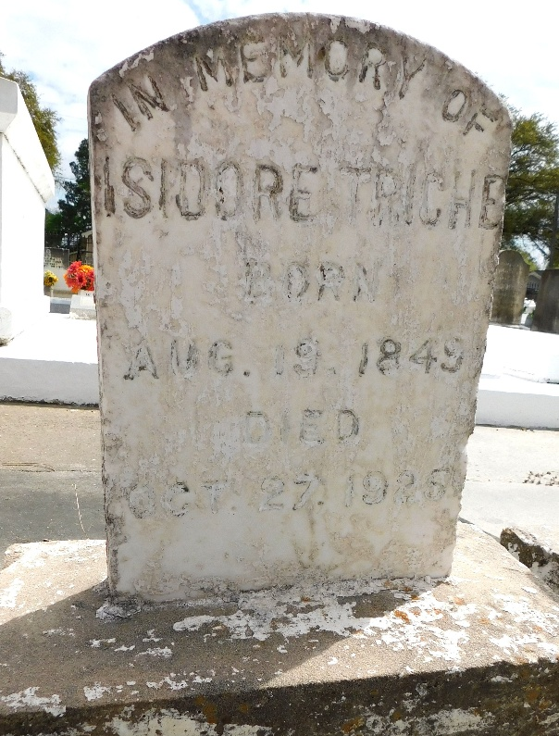
Photos by Mary Agnes Hammett

Isidore Triche, a native of St. John the Baptist Parish, Louisiana, died at the home of his daughter Mrs. Ulysse Kilchrist in Port Neches, Texas, on Tuesday night, 27 Oct 1925.

He was the husband in first marriage of the late Marie Rosa Lasseigne and in second marriage of Philomene Triche. He was the father of Alcide Triche, Norbert Triche, Mrs. A. Thibodaux of Amelia, Louisiana, Mrs. Ulysse Kilchrist, Mrs. Theo Delaune of Napoleonville, Louisiana, and Mrs. I. C. Cole of Fordoche, Louisiana.

Interment was Thursday, 29 Oct 1925, in St Peter Cemetery, Reserve, Louisiana.

Unknown source

