Joseph Emilien Triche
April 20, 1873 – February 17, 1962

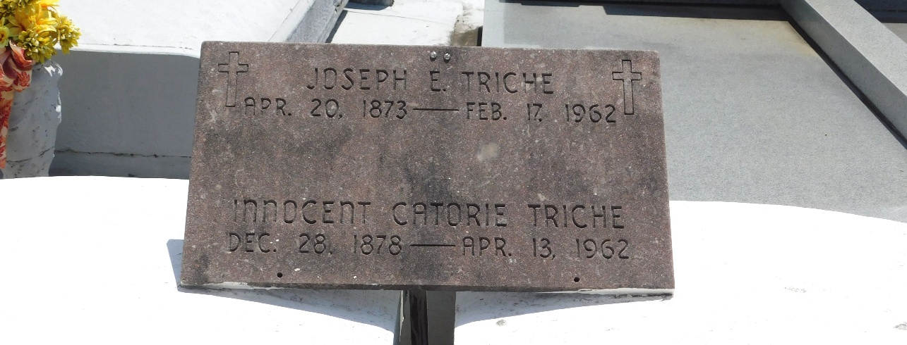
Photo by Mary Agnes Hammett

TRICHE – On Saturday, February 17, 1962, at 4:30 o’clock a.m., Joseph E Triche, beloved husband of Marie Innocent Catoire; father of Mrs. Clotilde Triche Schexnayder, Mrs. Idele Triche Duhe, Ernest Triche Sr., and Lawrence Trice and the late Mrs. Adeline Triche Perilloux and Clarence Triche; brother of Victor Triche, Mrs. Victorine Jacob and Josephine Triche Vicknair. Also survived by 19 grandchildren and 31 great-grandchildren. Age 90 years. A native and a resident of Laplace, Louisiana.

Relatives and friends of the family are invited to attend the funeral. Services from Millet Funeral Home, Laplace, Louisiana on Sunday, February 18, 1962 at 3 o’clock p.m. Religious services at St. Joan of Arc church, Laplace, Louisiana. Interment in St. Peter cemetery, Reserve, Louisiana.

The Times-Picayune, New Orleans, Louisiana
March 18, 1962

