Lena (Rodrigue) Triche
June 6, 1918 – May 4, 2008

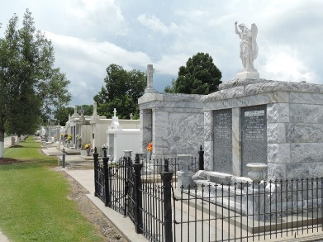

Lena Rodrigue Triche entered eternal rest on Sunday, May 4, 2008, at 11:15 a.m. She was 90, the beloved wife of the late Lawrence M. Triche.
Also preceded in death by her parents, Rene and Alanda Rodrigue; and beloved son, Melvin Triche.
She was the beloved mother and mother-in-law of Dorrel J. Triche Sr. and Mary Lambert Triche, and Helen Weber Triche, beloved sister of Earl Rodrigue, of Destrehan, and the late Curtis, Tennyson and Herbert Rodrigue, grandmother of Cindy Ware, Kevin, Keith, Dorrel Jr., Michael, Gregg and Douglas Triche, great-grandmother of Shaunelle, Kevin Jr., Courtney, Alanda, Derek, Leslie, Cedric, Jay, Ben, Grace, Jeremy T., Jared, Angie, Amy, Nicole, Brian, Jacob, Jeremy V., Nathan and Jaime, great-great-grandmother of Jade, Samantha, Brayden and Josh, special mother to Gale, Charlene and Cherie.
Lena was a native of Chackbay and a longtime resident of LaPlace, where she was an active senior member of St. Joan of Arc Court of the Catholic Daughters.
Relatives, friends, members of the Catholic Daughters and residents of Place DuBourg are invited to attend the funeral service at St. Joan of Arc Catholic Church, LaPlace, on Tuesday, May 6, at 1 p.m. Visitation for family begins at the church at 10 a.m., with general visitation from 11 a.m. until service. Interment in St. Peter's Cemetery, Reserve. Arrangements by Millet-Guidry Funeral Home, LaPlace.
Advocate, The (Baton Rouge, Louisiana)
Monday, May 5, 2008

