Marie Innocent (Catoire) Triche
December 28, 1878 – April 13, 1962

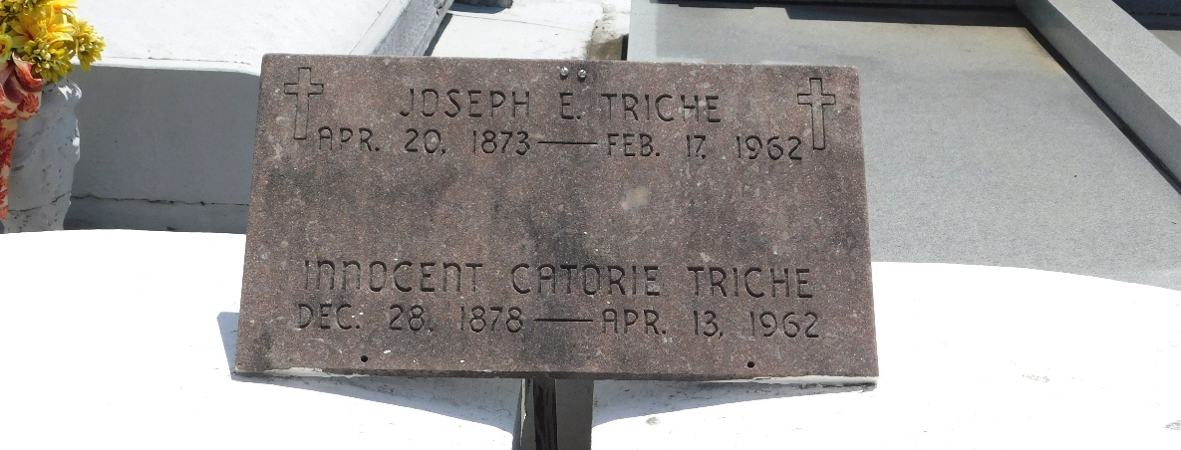
Photo by Mary Agnes Hammett

Marie Innocent Catoire Triche, wife of late Joseph Triche, died Friday, 13 April 1962, at age 83 years. She was a native and resident of Laplace, Louisiana.

Mother of Adele Triche Duhe, Ernest and Lawrence Triche and the late Clarence Triche.

Services were Saturday, 14 April 1962, at St Joan of Arc Church, Laplace, with interment in St Peter Cemetery, Reserve, Louisiana.

The Times-Picayune, New Orleans, Louisiana
April 14, 1962

