Paul Alcee Triche
November 18, 1917 – May 24, 2006

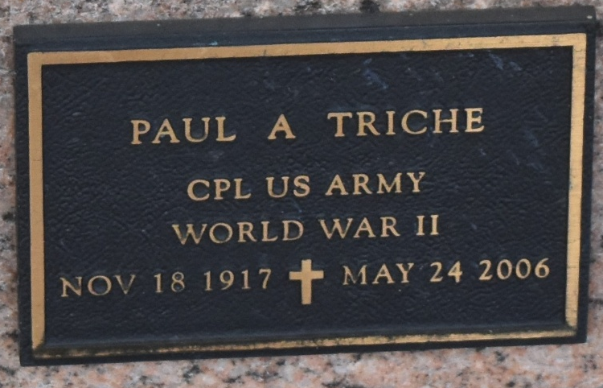

Paul Triche on Wednesday, May 24, 2006 at 4:14 P.M.
Beloved husband of the late Violet Hebert Triche. Father of Pauline (Poochie) and Marvin Triche. Father-in- law of Elaine Triche. Grandfather of Kim Strehile and Chet Triche. Great-grandfather of Madison and Baron Strehile and Cheyenne Triche.
Son of the late Alcee and Eva Triche. Brother of Alvin, Henry, Larry and Lawrence Triche and the late Roland Triche. Age 88. A native and resident of Reserve, LA.
Relatives and friends of the family, also American Legion and VFW are invited to attend services. Visitation at St. Peter Catholic Church, Reserve, LA. on Friday, May 26, 2006 from 9 AM to 11 AM. Followed by religious services at the church at 11 AM. Burial in church cemetery. Arrangements by Millet-Guidry Funeral Home, Laplace

The Times-Picayune, New Orleans, Louisiana
May 26, 2006

