Sharon (Simoneaux) Triche
December 3, 1946 – February 6, 2023

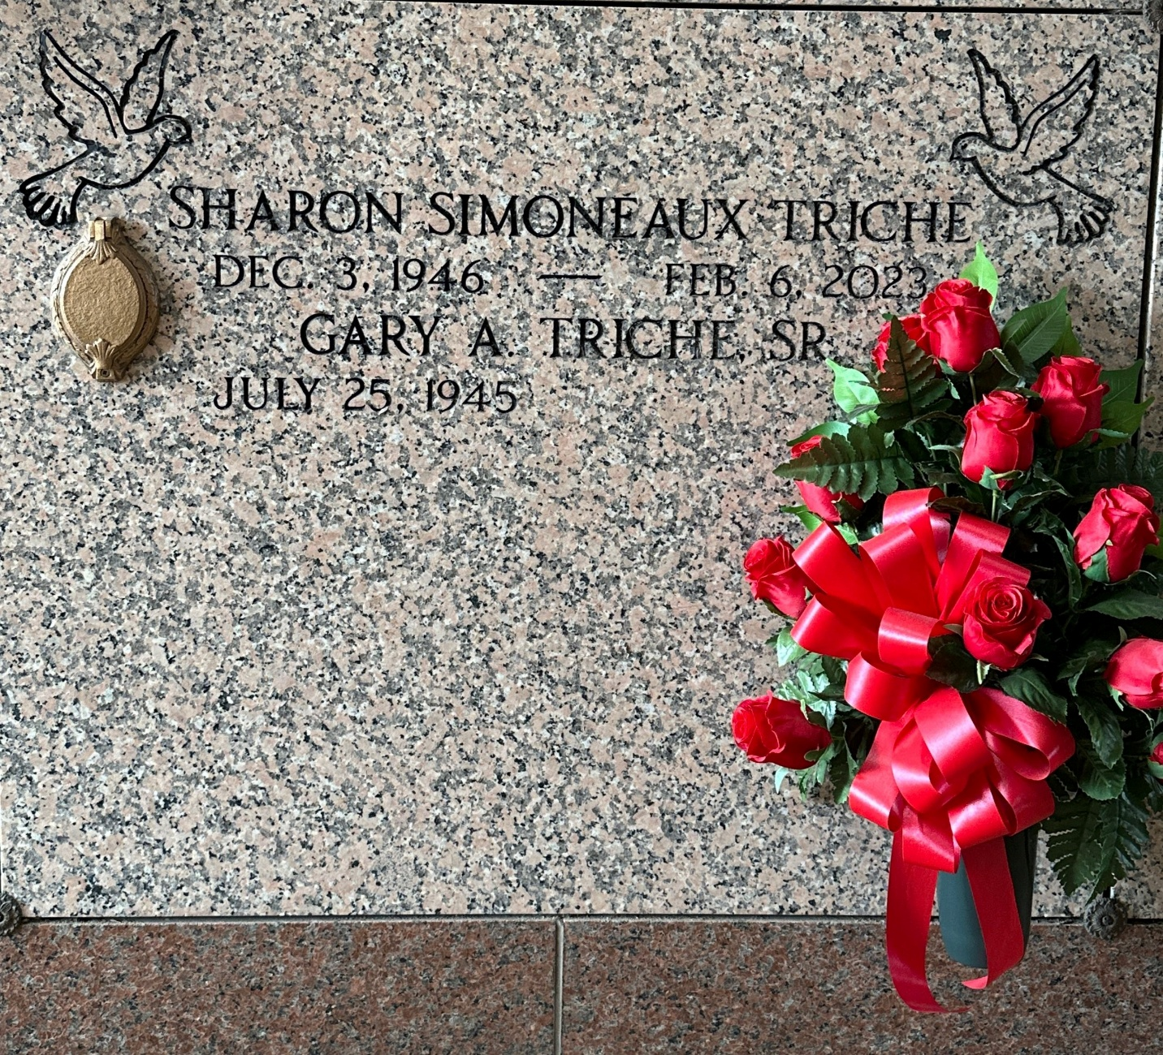
Photo by Team T-Lo

Sharon Simoneaux Triche passed away on February 6, 2023 at the age of 76. She was a lifelong resident of LaPlace, LA.
Sharon was the beloved wife of Gary A. Triche, Sr. Mother of Gary Triche, Jr., Wendy Capdeboscq (Kerry) and Rachel Hebert (John). Grandmother of Gary Triche, III, Ashley, Cory, Amy and Timmy Capdeboscq, Brandon, Allison and Peyton Hebert. Sister of Ralph Simoneaux (Debbie), Elaine Hintz (Henry) and Debra Roussel (Dwight).
She was preceded in death by her parents Murphy & Lilly Michel Simoneaux and her sister Brenda Lowry (Michael).
Relatives and friends are invited to attend a Funeral Mass at 11:00 AM on Friday, February 10, 2023 at St. Joan of Arc Catholic Church, 529 W. 5th Street, LaPlace, LA 70068. Visitation will begin at 10:00 AM. Interment will be in St. Peter Catholic Cemetery in Reserve, LA.
Millet-Guidry Funeral Home, LaPlace, Louisiana
February 8, 2023

