Sidney Joseph Triche
June 7, 1898 – June 7, 1956

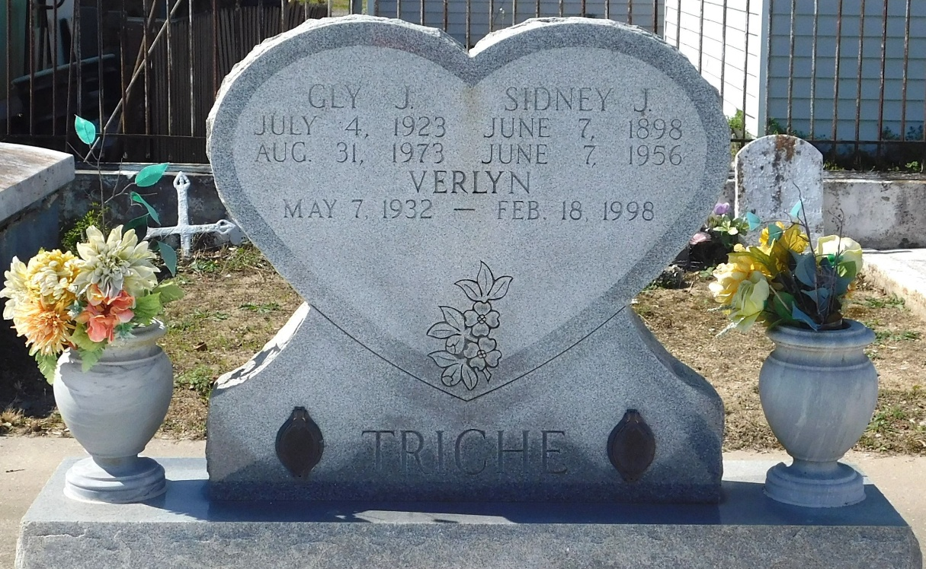
Photo by Mary Agnes Hammett

Sidney Triche died on Thursday, June 7, 1956, at 11:30 o'clock a.m.
He was the son of John Triche and Octavie Madere and the brother of Dennis Triche. He was the father of Mrs. Beatrice Ferrand, Mrs. Henrietta Clark, Raymond, Sidney, Henry, John and Richard Triche. Also survived by three grandchildren.
He was a native of Laplace, Louisiana, and a resident of New Orleans for the past 34 years. Aged 58 years.
Relatives and friends of the family, also the Culotta Seafood Company, the Shell Oil Company of Norco, Louisiana, and the New Orleans Armature Works, are invited to attend the funeral from Millet Funeral Home, Reserve, Louisiana, on Saturday, June 9, 1956. Interment in St Peter Cemetery, Reserve.
The Times-Picayune, New Orleans, Louisiana
7 Jun 1956

